
MUUGLines
The Manitoba UNIX User Group Newsletter
Volume 33 No. 4, December 2020 Editor: Bradford C. Vokey
Next Meeting: December 8th, 2020

Topic: RTFM: cal(1), Extended Round-Table, and Show-and-Tell
We have a tradition of making the December meeting more of an informal, social gathering. This year, because we're meeting online, we've had to let go of some of the traditional aspects of this year-end meeting (like food), but we'll try to keep some.

Show us your favorite gadget!

As part of an extended round-table discussion, we'll try to keep the gadget show-and-tell. This year, you don't have to haul it to the meeting site, but it will have to be small enough to show on your webcam!
If you have a cool device, something unusual, whether brand new or ready for the museum, there will be an opportunity to show it off.

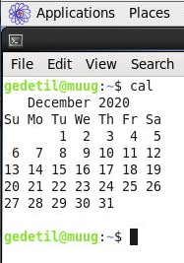
RTFM: cal(1) - A Histori-cal Look at Calendar Reform
As part of the September 2016 meeting, we looked at cal(1), and its ilk (ncal and gcal), mostly from a utilitarian point of view. This time, we'll look at some of the historical development of this command, as well as some strange quirks of calendar reform. Why was the year 2000 a leap year, but 1900 wasn't? (At least for most of the world.) Why was 1700 a leap year in many Protestant countries, but not in Roman Catholic ones? What was going on in 1752 for England and her colonies? Gilbert Detillieux will answer these questions, as we delve into the politics and religion involved in calendar reform.
Where to Find the Meeting:

jitsi.merlin.mb.ca/muug.2020.12

This month (just like last month) we are using our own online Jitsi meeting server hosted by merlin.mb.ca.
The virtual meeting room will be open by 7:00 pm on December 8th, with the actual meeting starting at 7:30 pm. You do not need to install any special app or software to use Jitsi: you can use it via any modern webcam-enabled browser by going to the aforementioned link.
After joining the meeting, please:
- Keep yourself muted (or stay quiet) while others are speaking.
- Update your screen name from Fellow Jister to your actual name (click on your video thumbnail to edit your name).
- Use the chat function to get help if you need it.
- If you are using a browser, typing [?] will provide you with a list of Jitsi keyboard shortcuts.

Thank you MERLIN (the Manitoba Education Research and Learning Information Networks) for providing the hosting and bandwidth for our meetings.

Winnipeg Harvest
We won't be able to collect food and cash donations this year, but please remember that the needs for some may be greater than usual.
We encourage you to donate to Winnipeg Harvest, or your favourite local charity.
Meet Your New Board
The MUUG Board for the 2020-2021 year was elected by acclamation at the November general meeting.

Your board now consists of 10 members:
- Alberto Abrao
- Trevor Cordes
- Troy Denton
- Gilbert Detillieux
- Kevin McGregor
- Katherine Scrupa
- Adam Thompson
- Tyhr Trubiak
- Brad Vokey
- Wyatt Zacharias
A big thank you to all the nominees who let their names stand for election and welcome to Alberto for joining the MUUG board this year.
Board Positions
Your new board held their first board meeting on November 17th, and for the 6th year in a row they elected the same executive positions/officers (as per our by-laws) with no vote tampering needed!
President: Wyatt Zacharias
Vice-President: Trevor Cordes
Secretary: Gilbert Detillieux
Treasurer: Brad Vokey
We also appointed the following unofficial officers:
Social Media Ninja: Brad Vokey
Executive Jitsi Concierge: Troy Denton
Door Prize Don: Trevor Cordes
We do endeavour to have fun at our board meetings!
Your banking committee continues as:
Brad Vokey, Gilbert Detillieux and Kevin McGregor.
Your server committee is now:
Adam Thompson, Trevor Cordes, Wyatt Zacharias, and Katherine Scrupa.
The new board looks forward to serving you over the next year. If you have any questions or requests, feel free to send an email to <board@muug.ca>.
December Door Prizes:
Last month's physical book did not get picked (everyone picked e-books)! So along with our usual selection of e-books we still have to give away:


Ambient Findability
by Peter Morville [O’Reilly 2005]
Pages: 181
How do you find your way in an age of information overload? How can you filter streams of complex information to pull out only what you want? Why does it matter how information is structured when Google seems to magically bring up the right answer to your questions? What does it mean to be “findable” in this day and age? This eye-opening new book examines the convergence of information and connectivity.
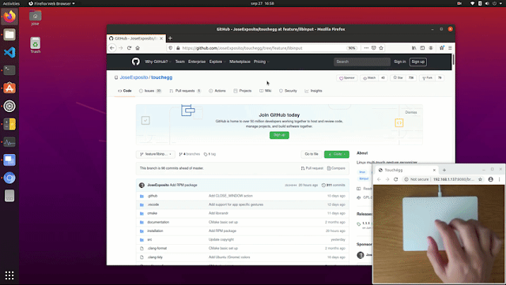
Touchégg
Multi-touch gestures for Linux
Touchégg is a multi-touch gesture recognizer for Linux that was first released back in 2011, and was completely rewritten about 2 months ago. Since then there have been 3 new releases which have added several new features along with bug fixes.
With Touchégg, you can swipe up with 3 fingers to maximize a window or swipe left with 4 finger to switch to the next desktop.
Many more actions and gestures are available and everything is easily configurable.
Packages are available for most distributions.

https://github.com/JoseExposito/touchegg
MUUG Annual Financial Statements

By Bradford C. Vokey, MUUG treasurer
Here are your MUUG 2019-2020 annual financial statements.
Unfortunately, our membership has declined by 11 members over this difficult year and we now have a total of only 40 paying members.
The MUUG server/mirror will soon require an upgrade to help improve its performance. Your board will continue to slowly and carefully use our built up surplus to continue serving the UNIX/LINUX/BSD community here in Manitoba.
As per our bylaws (11.(h)) “The books and records of MUUG may be inspected by any member at the Annual Meeting or at any time upon not less than fourteen days notice in writing to the Executive.”

Happy 25th Birthday GIMP
https://www.gimp.org/news/2020/11/21/25-years-of-gimp/
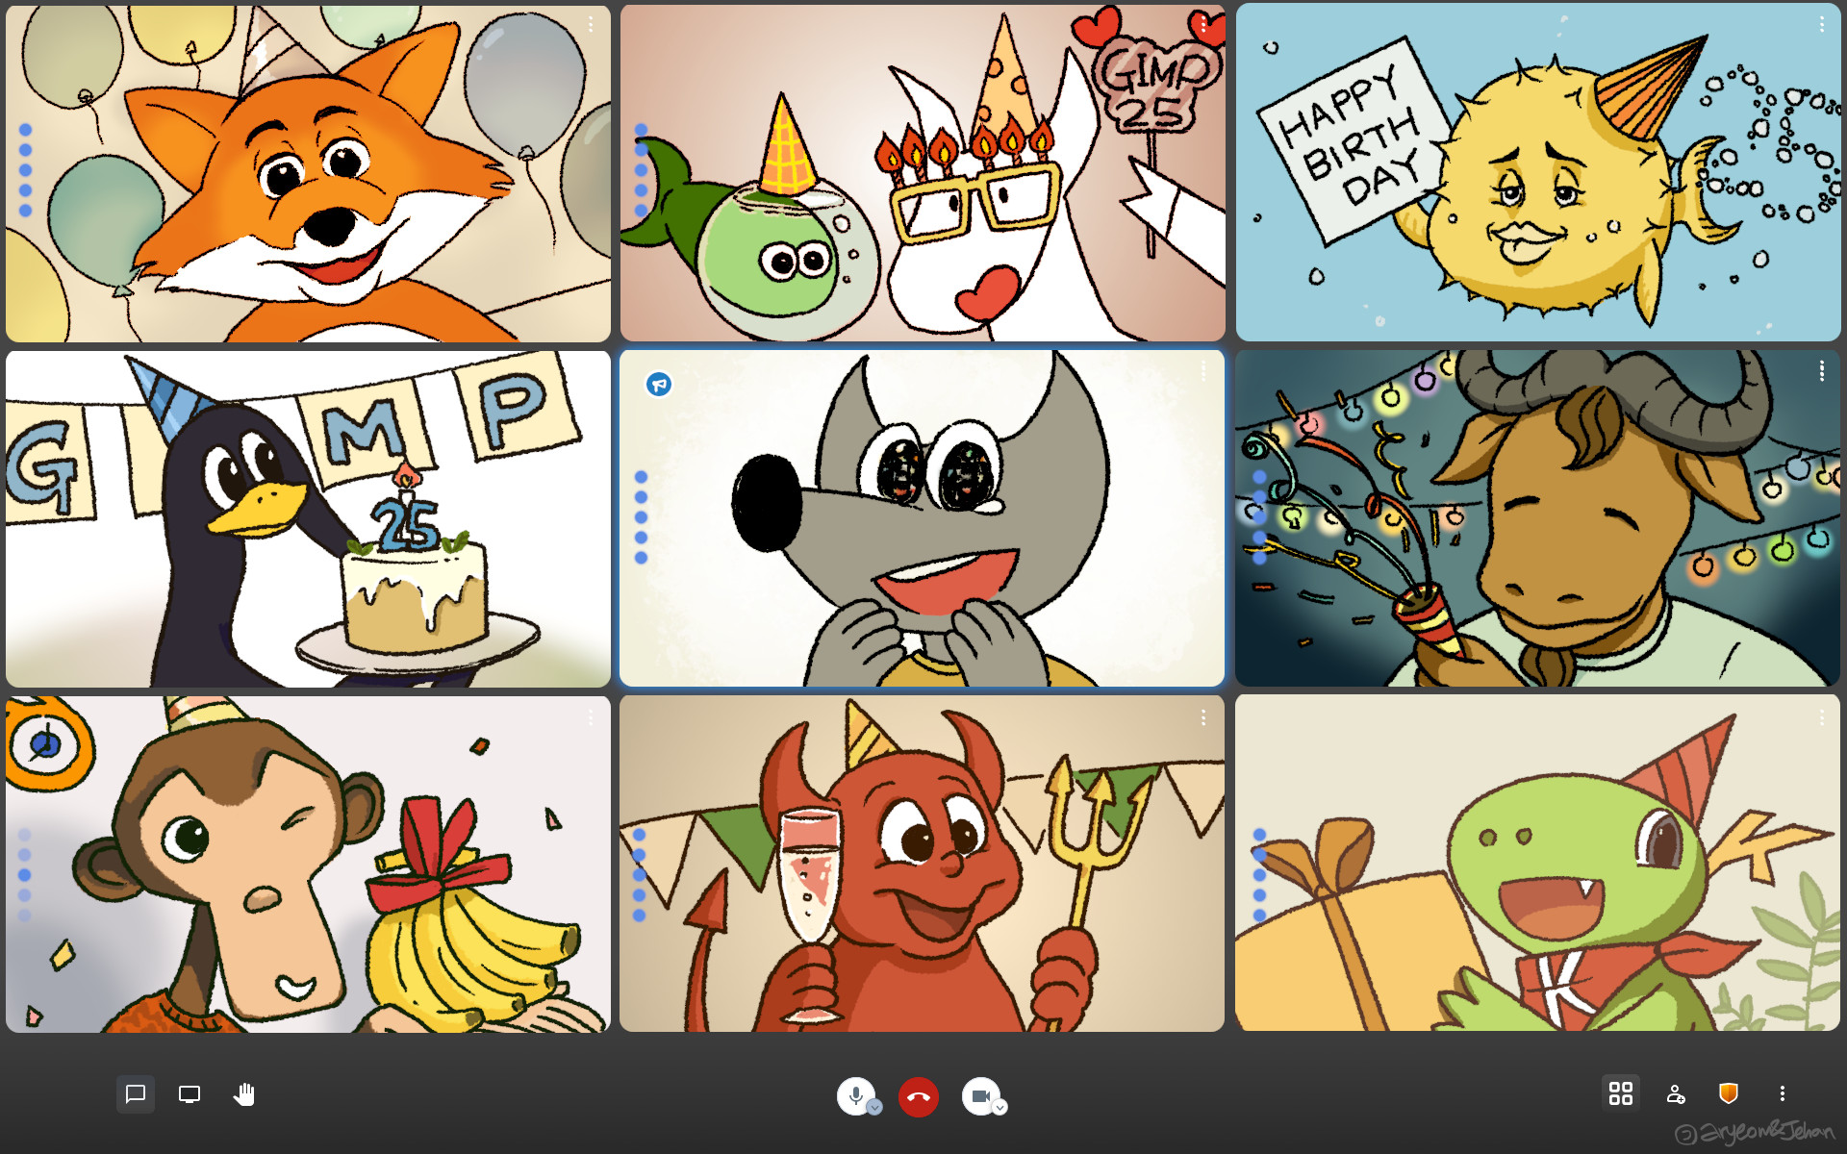“Happy 25th birthday GIMP!” by Aryeom,
Exactly 25 years ago, Peter Mattis wrote a message to several newsgroups announcing a new image editor called GIMP.
Here is what gimp.org has to say about it:
We’ve been really busy ever since!
- Had to come up with GTK, a user interface toolkit of our own. Did not expect whole desktop environments, like GNOME and Xfce, to become the result of that. GTK is now a self-contained project used by thousands of developers.
- Surprisingly, got a few developers from Hollywood to write the beginnings of what became a new image processing engine called GEGL, now used by a few more software projects too. We still have barely scratched the surface of what’s possible with GEGL.
- Introduced Wilber, a little cute mascot who traveled the world and, admittedly, did some kinky things. They grow up so fast! (Check out the splash screen archive)
- Helped kickstart Libre Graphics Meeting as an extended version of our annual meetup in 2006. Made a lot of new friends every year since then.
- Did our best to provide a sensible workflow to users by using common user interface patterns. That gave us a few questionable monikers like ‘Photoshop for Linux’, ‘free Photoshop’, and ‘that ugly piece of software’. We still can wholeheartedly agree with the latter one only!
- Tried to do too many things at once with too few active developers to realistically get things done in a sensible timeframe. Made a lot of people think the project died while we were slaving away really. So we introduced some planning. It’s been paying off so far.
- Made more people angry with software’s quirks than we’d like to. Got help on that from more passionate contributors than we expected to. We can certainly use more help still.
- Got ourselves an animation project called ZeMarmot to make a positive feedback loop involving artists and developers. Continue using our chat for conversation with artists, some of which put GIMP through a lot. That really helps.
- Every day, we are one step closer to completing the boring yet extremely important work on refactoring GIMP to make way for great new things. Things that we’ve been meaning to do for a long time. Things that users have been expecting for an even longer time.
The world is definitely a different place 25 years later. Louder, noisier, more demanding. Definitely less safe. But also full with warmth and humanity. We’ve seen waves of that washing up and down the rocky shores of GIMP.
We don’t really have any kind of big news for you to commemorate the anniversary. Sorry about that. We keep slaving away — in a more intelligent way these days, hopefully. But there might be cake.
LibreOffice 7.1 Office Suite Enters Beta
Promises a Plethora of Improvements

After about six months of development, the upcoming LibreOffice 7.1 office suite is now ready for public beta testing. The first beta release has arrived and anyone willing to help the development team discover and fix bugs can download it right now from the official website for Linux, macOS, and Windows platforms. LibreOffice 7.1 has a plethora of improvements and some exciting new features and is scheduled to be fully released at the beginning of February, 2021.

https://wiki.documentfoundation.org/ReleaseNotes/7.1
This user (who recently updated to version 7.0.3.1 to write this newsletter) is looking forward to the new Styles Inspector for displaying all the attributes of Paragraph Styles, Character Styles and manually formatted (Direct Formatting) properties.

PHP 8.0 released
PHP 8 was released on November 26, 2020. It's a new major version, which means that it will introduce some breaking changes (sigh), but it brings in lots of new features and performance improvements.
PHP turned 25 earlier this year and its latest iteration brings a variety of improvements to those who enjoy the language, which certainly isn't everyone. However, with 79% of websites still using PHP, even if you don’t like it or use it, you will eventually have to deal with it.
Some of the notable new features are union types, named arguments, and a new match expression.
https://www.php.net/releases/8.0/en.php
Final Exam

https://xkcd.com/2385/

Share Your Thoughts

Please email MUUG with your comments and suggestions regarding the newsletter and the meetings. Whether it’s criticisms or commendations, we want to hear from you. Specifically, what sort of material would you like to see and/or hear about.
Send an email to: board@muug.ca.
Thank You Les.net
A continued thank you to LES.net for providing MUUG free hosting and bandwidth for our server and mirror. Les.net (1996) Inc. is a local provider of VoIP, Internet and Data Centre services. Contact sales@les.net or call 204-944-0009.

https://les.net/
Creative Commons License

Help us promote this month's meeting, by linking to this poster on your various social platforms:

https://muug.ca/meetings/MUUGmeeting.pdf

Except where otherwise noted, all content in this newsletter is licensed under a Creative Commons “Attribution-ShareAlike 2.5 Canada” License.
http://creativecommons.org/licenses/by-sa/2.5/ca/deed.en_CA

