
MUUGLines
The Manitoba UNIX User Group Newsletter
Volume 34 No. 2, October 2021 Editor: Tyhr Trubiak
Next Meeting: October 12th, 2021 (Online Video Meeting)

Feature Presentation: Ardour – audio software

This month, Troy Denton will be presenting Ardour.
Available on Linux (as well as macOS and Windows), Ardour allows you to record, edit, mix and master audio and MIDI projects. If you are an audiophile, or a beginner wanting to know how to get into audio manipulation, or just curious and like to see audio represented graphically, then this presentation is for you.

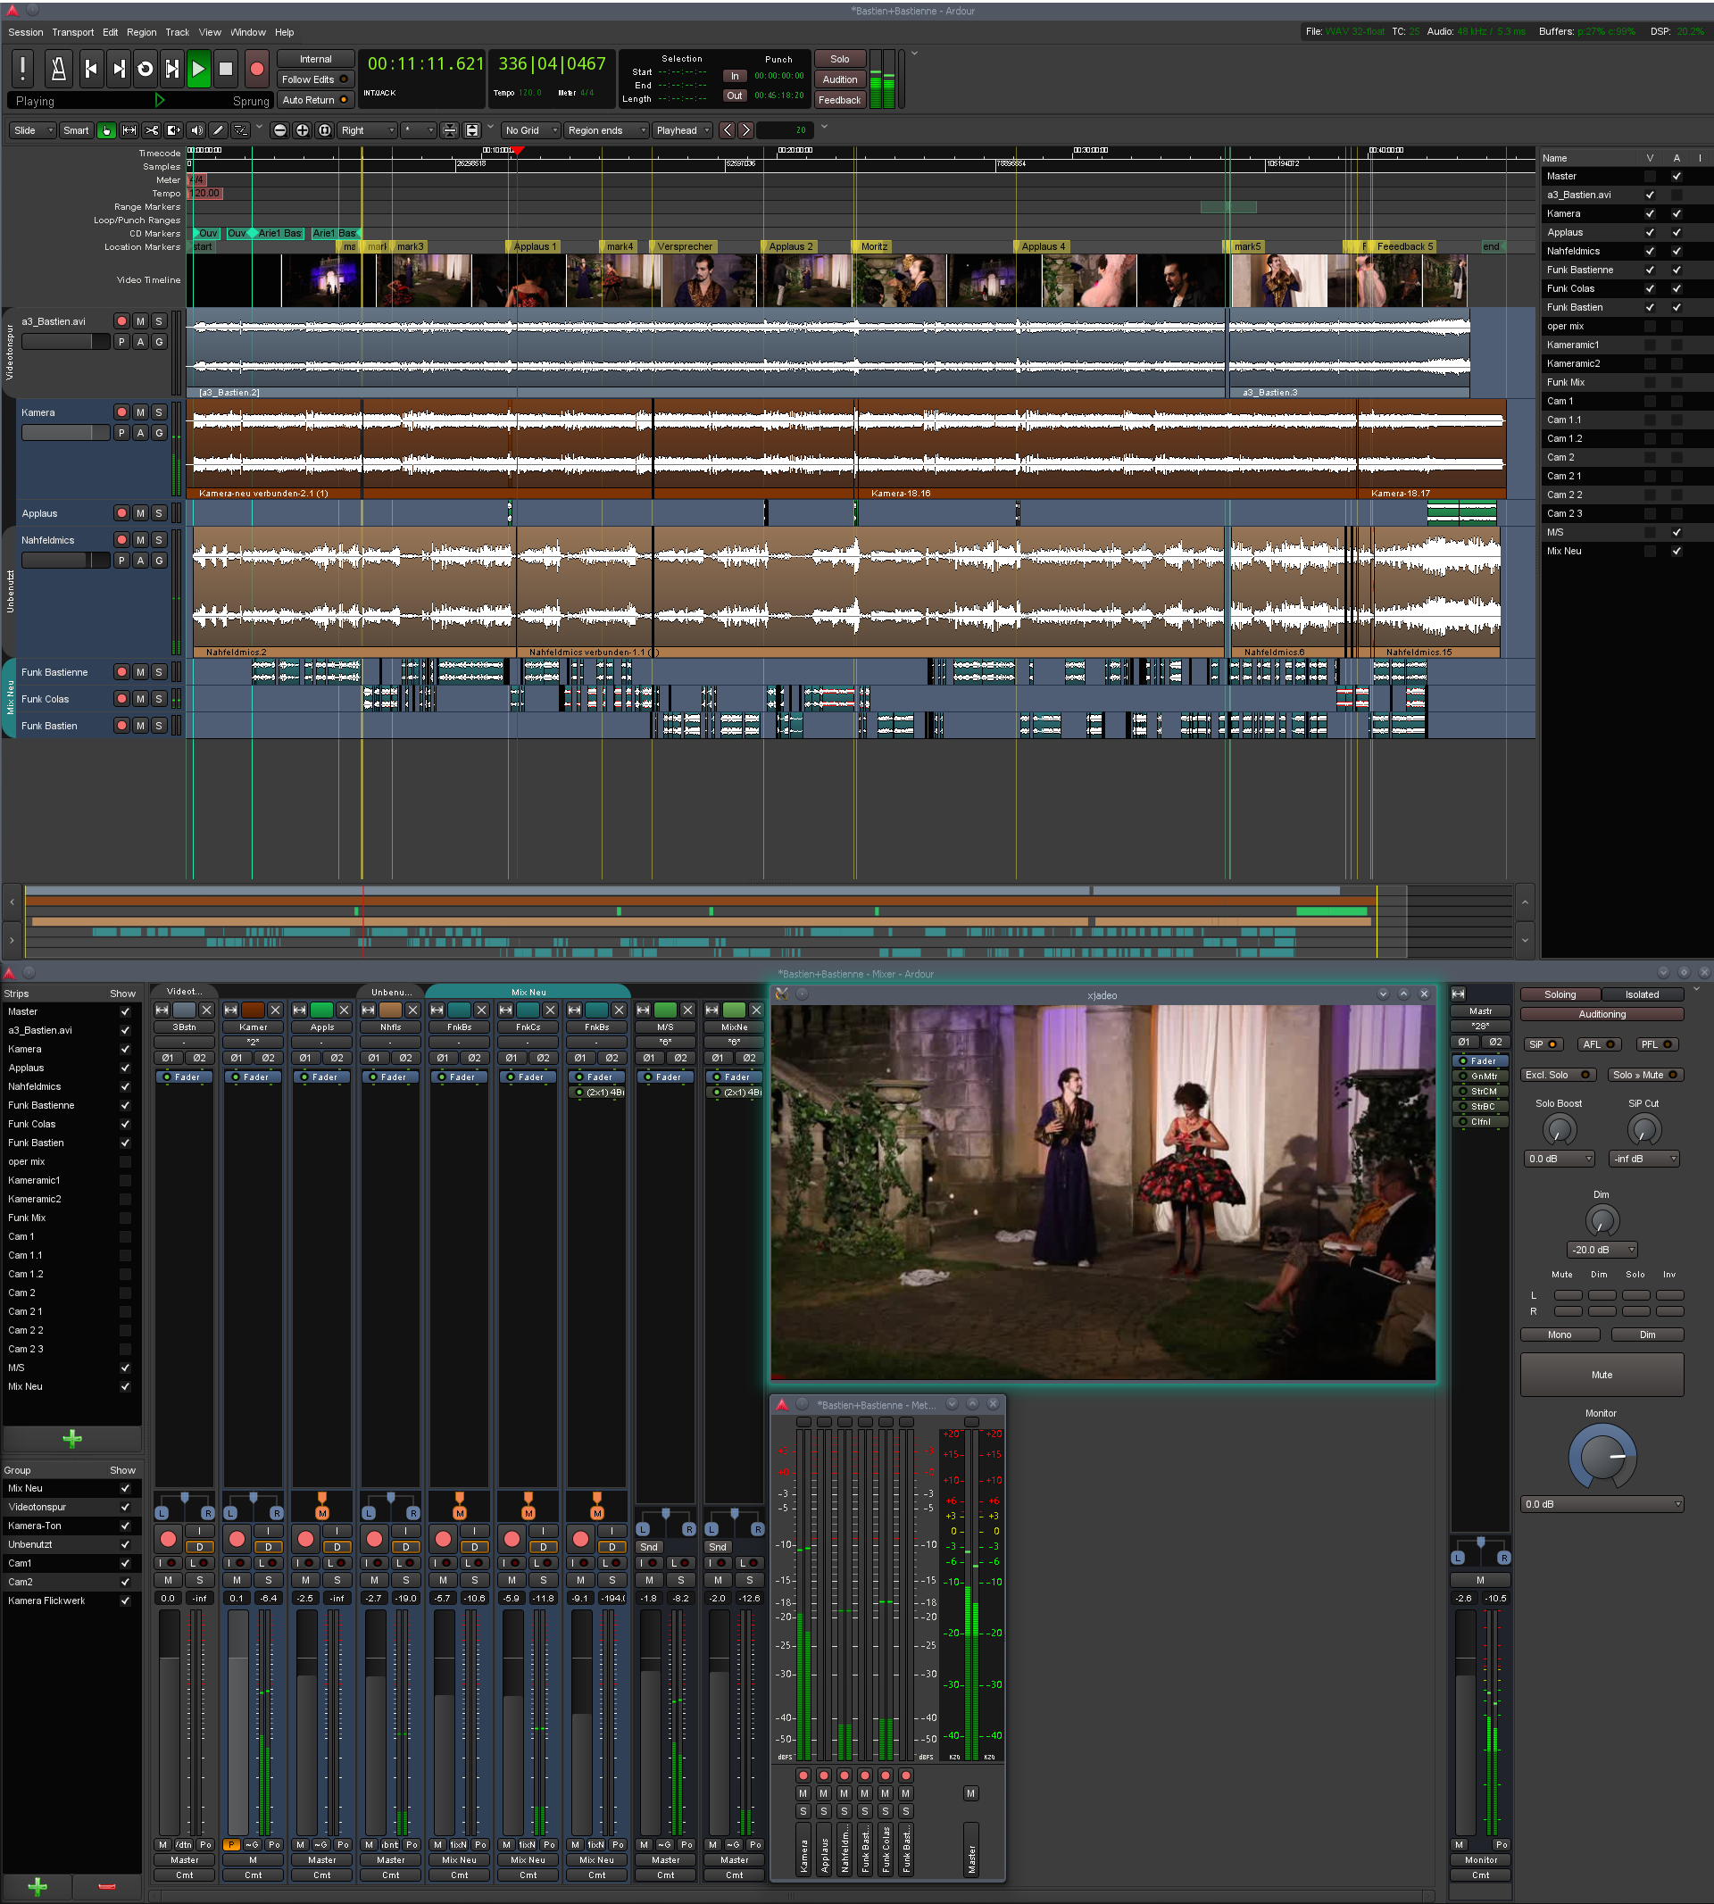
The latest meeting details are always at:

https://muug.ca/meetings/
RTFM
Katherine Scrupa will be talking about grepcidr, a tool that filters input by IP addresses and networks, using both IPv4 and IPv6.
The grepcidr command can be very useful in networks, including mail filtering, network security and log analysis.
Where to Find the Meeting:
This meeting will be utilizing a different video conferencing server than usual due to a migration away from our previous MERLIN hosting.
We will be running Big Blue Button instead of Jitsi, but the link will be the same. It is recommended to log in early to familiarize yourself with the new controls. Please watch the MUUG website for details as they become available:

https://muug.ca/
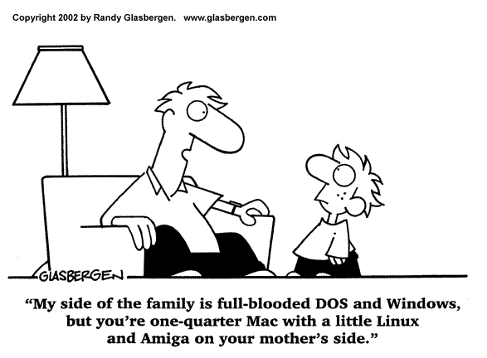

The October meeting will once again be BYODAS (bring your own drinks and snacks), as we have not yet perfected the technology to deliver goodies through the ether, but I’ve heard of POP over email...and cookies on websites...
MUUG Board Elections
Call for Nominations

Adam Thompson, Nomination Committee Chair Calling all nominations!
This is the preliminary call for nominees to participate in this year’s MUUG Board election. Those elected will serve on the MUUG board from November 2021 to November 2022. Any MUUG member in good standing may nominate someone they feel would make a good candidate, including themselves. The MUUG Board is tasked with coordinating the meetings and other events hosted by the group. It’s fun, and you get a role in deciding what the group will do. All members are encouraged to apply. Every November, the group holds its annual general meeting, the main goals of the meeting are to elect the new board, and to pass any special resolutions if required. The Board may consist of up to 10 people. The following 10 members are allowing their names to stand for re-election:
Wyatt Zacharias
MUUG President
Senior Cloud Developer – Wawanesa Insurance

Trevor Cordes
MUUG Vice-president
Owner – Tecnopolis Enterprises

Brad Vokey
MUUG Treasurer/Social Media
Owner – Fortress Software

Gilbert Detillieux
MUUG Secretary
Systems Analyst – University of Manitoba

Alberto Abrao
IT Support Specialist - Canadian Centre for Child Protection

Troy Denton, P.Eng
Engineer – Intel

Kevin McGregor
Systems Specialist – City of Winnipeg

Katherine Scrupa
Systems & Network Administrator – Steinbach Credit Union

Adam Thompson
Consultant, Infrastructure Services – MERLIN

Tyhr Trubiak
Systems Administrator – AFNCloud
Linus Torvalds Loves NTFS!
Ok, maybe Linus did NOT say that he loves NTFS. However, he did agree to include Paragon Software’s NTFS3 kernel driver, which will give the Linux kernel 5.15 release improved support for Microsoft’s NTFS file system.
GNOME 41 Released

New in the GNOME Control Center is a Multitasking settings panel that gives you control over window management and workspace multitasking options like the Activities hot corner, Active Screen Edges, the ability to show workspaces on all displays, choose between dynamic or fixed workspaces, and restrict app switching to the current workspace.
Performance - a new power mode setting which will be available on hardware that supports this feature, increasing CPU performance to allow your apps and activities to run faster.

Power Saver has been enhanced to dim/fade rapidly and turn on when the battery level is low.

Mobile Network configuration of connections like 2G, 3G, 4G and GSM/LTE.

Connections app offers a more modern remote desktop client that supports both VNC and RDP connections.

Other changes include support for creating encrypted .zip archives in the files manager, ability to import events from .ics files in the Calendar app and improved mobile device window resizing.

https://9to5linux.com/gnome-41-desktop-environment-officially-released-this-is-whats-new
Stealth Malware for Linux
Found Inside WSL (Windows Subsystem for Linux)

Black Lotus labs found malware that was attacking PCs and surpassing the security systems checks. The malware was distributed via ELF (Executable and Linkable Format) files, and primarily targets Debian and it’s related distros.
Black Lotus labs found several version of ELF files that were infected, including one using Windows Powershell that could access specific Windows API and others infecting common Python libraries.
The malicious files, written primarily in Python and compiled in ELF acted as loaders running a payload that would be injected into a running process using Windows API calls. This technique gave a near zero detection rate by most virus checkers at the time.
It is recommended to ensure proper logging is enabled if you are running WSL.

https://blog.lumen.com/no-longer-just-theory-black-lotus-labs-uncovers-linux-executables-deployed-as-stealth-windows-loaders/
Ubuntu Pushes Back End of Life

Both Ubuntu 14.04 and Ubuntu 16.04 Extended Security Maintenance (ESM) support has been extended to 10 years.
Ubuntu 14.04 users will continue to receive operating system updates until April 2024, while Ubuntu 16.04 will continue until April 2026.

https://www.linuxtoday.com/developer/ubuntu-14-04-and-ubunu-16-04-support-has-been-extended-to-10-years/

Twelve Vulnerabilities Patched
With Latest Ubuntu Linux Kernel Security Updates
The Linux 5.4 LTS kernel in Ubuntu 20.04 and Ubuntu 18.04 LTS, as well as the Linux 5.11 kernel in Ubuntu 21.04 fix a number of security issues, including CVE-2021-33624, a security flaw discovered by Ofek Kirzner, Adam Morrison, Benedict Schlueter, and Piotr Krysiuk, which could leading to a side-channel attack, allowing an attacker to expose sensitive information, as well as CVE-2021-3679, a security issue discovered in the tracing subsystem that could allow a privileged attacker to cause a denial of service.
OBS Studio 27.1 Released
OBS Studio, used by some of our presenters here at MUUG (and a previous MUUG presentation itself), has added YouTube integration with version 27.1. This feature helps users connect their YouTube account without using a steam key, and make managing their streams easier, with controls for privacy settings, description, title, scheduling, etc.
MUUG officially does not advocate that you should quit your job to become a full-time YouTube content provider/influencer, but this definitely should be of interest to you should you choose to.

https://www.linuxtoday.com/developer/obs-studio-27-1-released-with-youtube-integration-18-scene-multiview-option-and-more/
Distributions of Linux Specialized by Some Governments:
- China: Ubuntu Kylin
- Turkey: Pardus
- Russia: Astra Linux
- Vienna, Austria: Wienux
- Venezuela: Canaima
- The White House uses a Red Hat-based OS (no fancy name?)

https://hostingtribunal.com/blog/linux-statistics/#gref
Fun Linux Statistics
- in 2021, 100% of the world’s top 500 supercomputers run on Linux
- 23 of the top 25 websites are using Linux (2 are not).
Note, this is according to Alexa, so I’m sure there is no bias there at all....
- 96.3% of the world’s top 1 million servers run on Linux...although I’m not clear on what a “top” server is in this statistic
- 90% of all cloud infrastructure run on Linux
- 1.93% of desktops worldwide run Linux
- 85% of all smartphones are based on Linux...the number of smart users on the other hand may be less...
- 83.1% of developers say Linux is their preferred platform to work on, while 54.1% of professional developers actually use Linux as their platform in 2019
- Where is Linux most popular globally?
India, Cuba and Russia.
- Where is Linux most popular in the United States?
Utah and California
- Where is Linux most popular in Canada?
(It did not say, but I’ll pretend it’s Winnipeg. We have some of the most amazing members at MUUG.)
- 90% of Hollywood’s special effects are made on Linux
- 90% of the public cloud run on Linux
- Every space program uses Linux, including the recent SpaceX Falcon 9.

https://hostingtribunal.com/blog/linux-statistics/#gref

A big thanks to Les.net for providing MUUG with free hosting and all that bandwidth! Les.net (1996) Inc. is a local provider of VoIP, Internet and Data Centre services. Contact sales@les.net by email, or +1 (204) 944-0009 by phone.

Help us promote this month’s meeting, by putting this poster up on your workplace bulletin board or other suitable public message board:

https://muug.ca/meetings/MUUGmeeting.pdf
Thank You Michael W. Lucas

MUUG would like to thank Michael W. Lucas for donating one of his ebooks every month as a door prize.

You can view and purchase his tech books here:
https://www.tiltedwindmillpress.com/product-category/tech/
Creative Commons License

Except where otherwise noted, all textual content is licensed under a Creative Commons Attribution-ShareAlike 4.0 International License.

https://creativecommons.org/licenses/by-sa/4.0/

