

MUUGLines
The Manitoba UNIX User Group Newsletter
Volume 34 No. 9, May 2021 Editor: Katherine Scrupa
Next Meeting: May 10th, 2021 (Online Big Blue Button Video Meeting)

Running Containers in the Cloud
With AWS Fargate
AWS Fargate is a serverless container solution that greatly simplifies the infrastructure required to run containerized applications. Without the need for Kubernetes or physical hosts, containerized apps can be quickly created and scaled with ease.
May Door Prizes:
Member draw, one e-book: any Mastery title by Michael W. Lucas. (https://mwl.io) Thanks Michael!
We’ll also have our usual e-book giveaway. We have added additional e-books since last month.
Where to Find the Meeting:
This month we will continue to use the open source meeting software: Big Blue Button. If you haven’t tried it yet, we recommend joining the meeting a little early to familiarize yourself with the controls. The virtual meeting room will be open by 7:00 pm on May 10th, 2022 with the actual meeting starting at 7:30 pm. You do not need to install any special app or software to use Big Blue Button: you can use it via any modern web-cam-enabled browser by going to the website link above. Please note that the meeting link will not be active until approx. 30 minutes before the actually meeting date and time.
The latest meeting details are always at:
https://muug.ca/meetings/
Museum of Obsolete Media
Remember 3.5-inch and 5.25-inch floppy disks? How about the 8-inch or 2-inch floppy? How about the Wheatstone tape or Tefifon? The Museum of Obsolete Media is an online museum based in the UK, describing and showing media formats that became obsolete from the 1880s (Ambrotype), to near today (McDonald’s Happy Meal music player, 2011) and in between (Soundmirror, 1954; CD-ROM postage stamps (2009). They also have a “wanted” list. Find them at:

https://obsoletemedia.org/obsolescence-decade/
Cunningham’s Law
Cunningham’s Law states:
“the best way to get the right answer on the internet is not to ask a question; it’s to post the wrong answer.”
The concept is named after Ward Cunningham, the inventor of wiki software. According to Steven McGeady, the law’s author, Wikipedia may be the most well-known demonstration of this law.
There is a similar French saying “prêcher le faux pour savoir le vrai” (“preach the falsehood to know the truth”).
So the next time you really need help on StackOverflow, also include a badly-crafted answer.

https://meta.m.wikimedia.org/wiki/Cunningham%27s_Law
The Universe is Hostile to Computers
Did you know particles from distant galaxies can create havoc on electronics, especially out in space? We’ve seen this in 2010 with space probe Voyager 2. It turns out the probe stopped transmitting because one of the bits on its encryption key was flipped.

https://www.youtube.com/watch?v=AaZ_RSt0KP8

https://astroengineer.wordpress.com/2010/05/12/voyager-2-has-flipped-its-bit/
Fingerprinting an Environment With ping and TTL
Linux/Unix ping will allow you to ping broadcast (255.255.255.255) with the -b option (allows ping to broadcast). Normally, Windows boxes won’t respond to it, but Linux/Unix boxes will. This can help you fingerprint a local network.
You can often fingerprint the OS by getting the TTL of an ICMP echo request. Most Linux devices have a default TTL of 64. Windows is usually 128, and Unix-based Operating Systems (e.g. AIX, HP-UX, Solaris, etc.) and some high grade network gear (e.g. Cisco, etc.) will use a TTL of 255. These values can be changed, but most admins don’t change them.

https://twitter.com/da_667/status/1515860377506041858?s=20&t=djVrnVuo4SnS8jpP9h-IxQ
Major Packaging Changes Coming to Fedora
Fedora has been using the DNF package manager for five years, but a year from now Fedora 38 will be using a new package manager called MicroDNF.
MicroDNF will to provide all the major features of DNF without losing its minimal footprint. The change proposal for this major upgrade of MicroDNF in Fedora 38 explains,
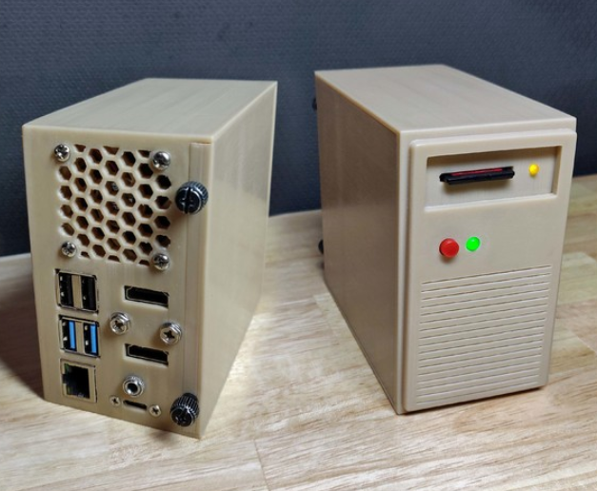
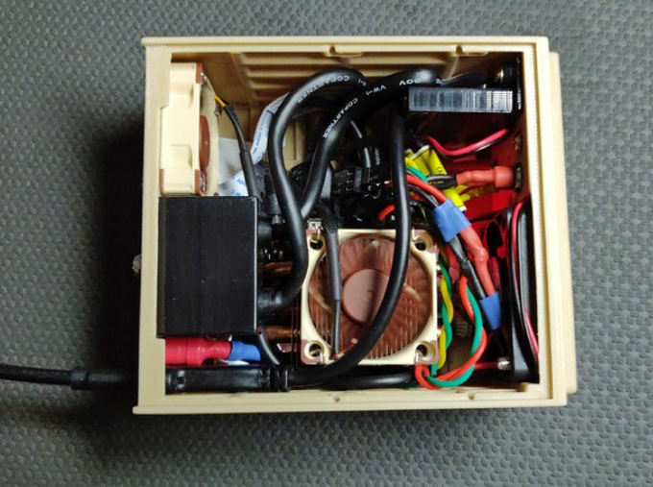
“The new major Microdnf will provide huge improvements and in some cases better behavior then [sic] DNF. In the future, the new Microdnf will replace DNF. The new Microdnf will be accompanied by a new library (libdnf5) and a new DNF Daemon.”
MicroDNF will provide better progressing reporting, better Bash completion, and improved transaction table, and more. The upgraded DNF library (libdn5) is expected to provide better modularity, a unified user interface, plug-in improvements, a new daemon, performance improvements, and more.
Since there is a change, note that some behavior / command-line interfaces and structural changes may not be exactly the same. One notable change is that removing a package will no longer trigger the removal of unused dependencies.

https://www.phoronix.com/scan.php?page=news_item&px=Fedora-38-MicroDNF
Welcome To BBEdit (30 Years)
On April 12, 1992, BBEdit html and text editor was unleashed upon this world. System 6 (Mac) users were happy to know it could run in a partition as small as 256K. The size of any file was only limited by the amount of memory available in BBEdit’s partition; there is no 32K upper bound.

https://groups.google.com/g/comp.sys.mac.announce/c/gvPGyuX3UCs
BSD Creator Bill Jolitz has Passed Away
In 1989, Lynne and Bill Jolitz foresaw the new x86 architecture as a dominant player in the future.
“There was an HP [Hewlett-Packard] port in progress and nothing else,” she says. “Since we were looking for recreation, we offered to do one for the 386.” “Completely as a lark,” Bill adds.
When porting, the pair reduced duplicate mechanisms and added extra capabilities other *NIXes had. The size was reduced by a factor of 35.
In 1992, the 386BSD 0.1 release had 250,000 downloads, including people who came to their doorstep.
Bill passed away about two months ago from a lengthy illness.
https://minnie.tuhs.org/pipermail/tuhs/2022-April/025643.html
https://www.salon.com/2000/05/17/386bsd/
3D-Printed Retro Raspberry Pi Case
Missing: turbo button

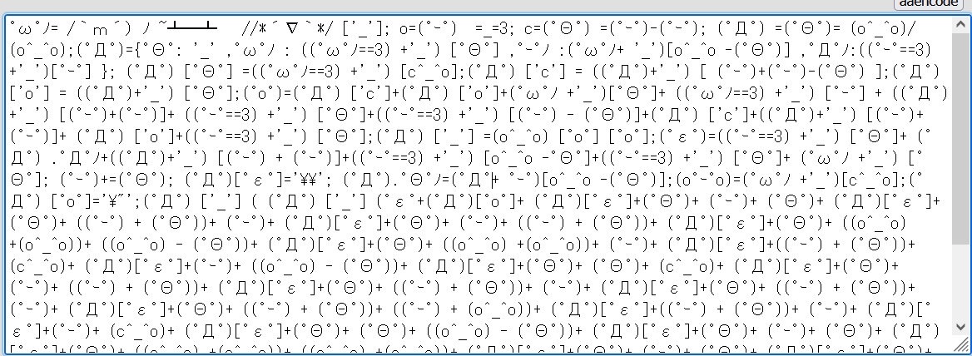

But it has a fan?
https://www.thingiverse.com/thing:5215750
Use 7-zip to Read Raw Disks
7-zip can extract exe’s, msi’s, and images (iso) in addition to “regular” zip files. However, 7-zip running as administrator can access raw disks —including those formatted as Linux filesystems.
https://www.kphonline.co.uk/2011/08/reading-raw-disk-images-with-7zip/
https://sourceforge.net/p/sevenzip/discussion/45798/thread/92ea3ca5/
GIMP Doesn’t Actually Redact When You Delete In an Alpha Channel
The “Delete” key on your keyboard leaves all selected pixels intact, even after saving as PNG. You can remove the extra channel the “deletion” makes by removing the channel.
Worse yet, a thumbnail may expose the entire “unredacted” image.
With a GIMP .png you can uncheck the option to “save color values from transparent pixels”. Or, use a proper redacting tool if it’s that important.
https://twitter.com/wdormann/status/1216023431801638915
Ubuntu 22.04 LTS released
This version uses the latest GNOME 42 desktop environment, but still uses apps from the GNOME 41 stack due to compatibility issues between GTK4 apps and Ubuntu’s Yaru theme. Apps that weren’t ported to GTK4 are from the GNOME 42 stack, such as the Nautilus (Files) file manager.
This is also the first LTS release with Wayland as its default (except for machines with NVIDIA GPUs, which will stick with X.org), which is a major milestone.
https://9to5linux.com/ubuntu-22-04-lts-jammy-jellyfish-is-now-available-for-download-this-is-whats-new
aaencode – Translate JavaScript into Japanese-style Emoticons
Code like:
alert("Hello, JavaScript")
Can be converted to something like this, and it will run.

This works because a Javascript identifier can contain anything that is considered a “letter” in Unicode, which includes “unusual” characters for English.
Links to the encoder / decoder and a detailed explanation below:
https://utf-8.jp/public/aaencode.html
https://medium.com/the-z/breaking-down-one-of-the-coolest-javascript-obfuscators-15b234f768c
Wordle in 50 Lines of Bash
The New York Times recently bought a version of the Wordle game for seven figures. Github user huytd made their own in 50 lines, which equates to about $20,000 a line.
Huytd’s version allows you to set an unlimited number of guesses, as opposed to the standard of a maximum of six.
https://www.theregister.com/2022/02/02/bash_wordle/

Thanks to Michael W. Lucas

MUUG would like to thank Michael W. Lucas for his offer of a free ebook. You can view and purchase all of Michael’s fiction and non-fiction titles here:

https://mwl.io/
Thank You LES.net
A big thanks to LES.net for providing MUUG with free hosting and all that bandwidth!


https://les.net/

$1,000 worth of Free Credit Card Processing!
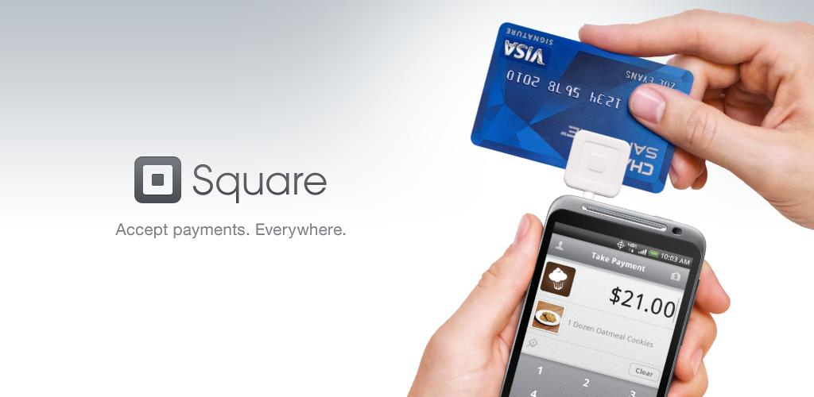
Sign up with Square (the credit card processor that MUUG uses at our monthly meetings) with the referral link below and both you and MUUG will receive $1,000 in free processing for the next 6 months (180 days).
You must use the following referral link for MUUG to receive the credit:

https://squareup.com/i/MANITOBAU1
Creative Commons License

Except where otherwise noted, all content in this newsletter is licensed under a Creative Commons “Attribution-ShareAlike 2.5 Canada” License.
http://creativecommons.org/licenses/by-sa/2.5/ca/deed.en_CA

