
MUUGLines
The Manitoba UNIX User Group Newsletter
Volume 34 No. 10, June 2022 Editor: Bradford C. Vokey
Next Meeting: June 14th, 2022
7:30pm - Online Video Meeting

Main Topic: nftables vs pf

Alberto Abrao will show us how to use nftables – the modern firewall subsystem of the Netfilter framework provided by the Linux kernel, and the successor to iptables – to create a basic firewall for your network.
He will also compare it to OpenBSD’s pf.

https://netfilter.org/projects/nftables/
Where to Find the Meeting:

https://muug.ca/meet
This month we will continue to use the open source meeting software: Big Blue Button. If you haven’t tried it yet, we recommend joining the meeting a little early to familiarize yourself with the controls.
The virtual meeting room will be open by 7:00 pm on the day of the meeting, with the actual meeting starting at 7:30 pm. You do not need to install any special app or software to use Big Blue Button: you can use it via any modern web-cam-enabled browser by going to the website link above.
Please note that the link to the meeting will not be active until approx. 30 minutes before the actually meeting date and time.
The latest meeting details are always at:

https://muug.ca/meetings/
MUUG BBQ: Tuesday, July 12th, 2022
MUUG is having a summer BBQ and everyone is invited!

Spouses, children, and significant others are also welcome to attend.
Date: July 12th, 2022
Time: 6:30 pm
Location: Brad’s place,
2942 Henderson Hwy,
East St. Paul
The MUUG board has decided it is time for all of us to try and get together in person – so we are hosting a BBQ event!
Burgers, hot dogs, and pop will be provided by MUUG. Feel free to bring your own food to share with others and your own beverages if you like.
Please RSVP via email to board@muug.ca with the subject “MUUG BBQ” before July 10th so we know how much food we need to buy.
Directions to Brad’s place:
- travel 1.9 km north of the Perimeter on Henderson Hwy.
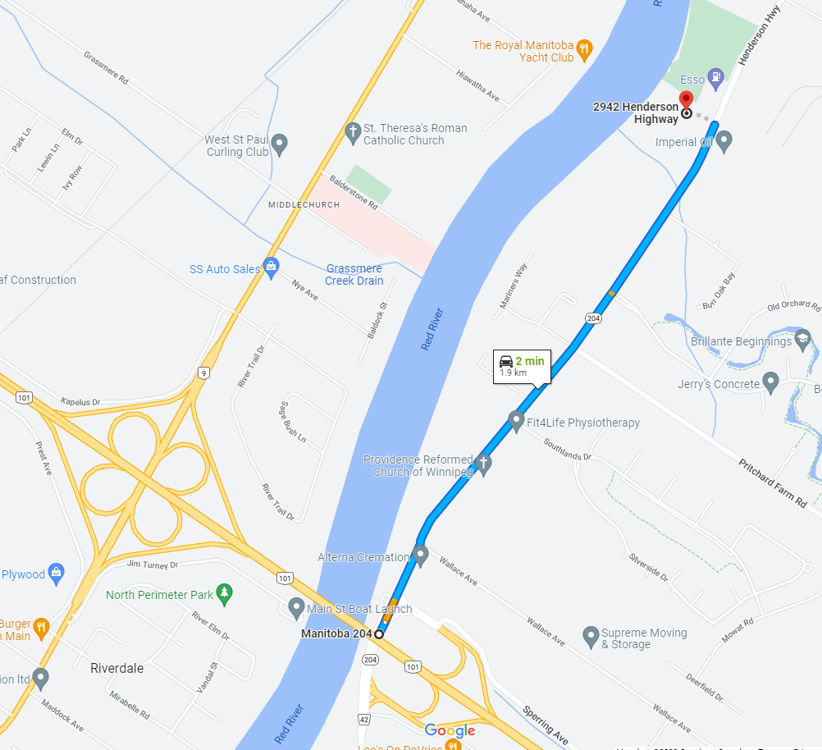
- When you see the Esso distribution center on your RIGHT, be prepared to turn LEFT.
- Brad’s place is the last driveway on the left before the Esso gas station. If you pass the gas station, turn around and come back one driveway. It is a shared driveway with 2942 on the left and 2946 on the right.
Continued on page 2...

...continued – MUUG BBQ – Directions to Brad’s place
- Stay left on the driveway (it splits 2 times).
- To park: turn yourself around on the parking pad in front of the garage doors to make it easier on yourself to get out later. Back in as close as you can to the garage. There is room for 4 cars in front of the garage and room for one (or two) more on the spare driveway which you will pass on the way in. If there is no more room, just park in front of someone and be prepared to move your car if needed. Parking on Henderson is possible but not recommended. There is also a large parking lot at the Esso gas station if you want to park there and walk in.
Questions? Call or text Brad @ 204-955-5691.
Lotus 1-2-3 Ported to Linux
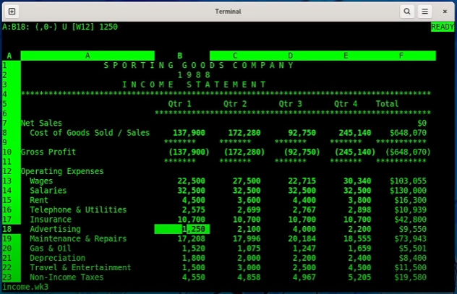
A long lost native Unix version of the killer PC spreadsheet has not only been rediscovered, but also updated to create a native Linux version.
Lotus 1-2-3 was arguably the single application which made the IBM PC a success, and was launched nearly 40 years ago, on January 26, 1983.
Google bug hunter Tavis Ormandy, of Project Zero, explains how he ported Lotus 1-2-3 natively to Linux here:

https://lock.cmpxchg8b.com/linux123.html
The blog post even talks about Xenix (Microsoft’s own version of Unix which was released in 1980).

Help us promote this month’s meeting, by linking this pdf to your workplace bulletin board or other suitable public message board:

https://muug.ca/meetings/MUUGmeeting.pdf
Charles Babbage’s Difference Engine Turns 200
Error-riddled astronomical tables inspired the first computer—and the first vaporware
It was an idea born of frustration, or at least that’s how Charles Babbage would later recall the events of the summer of 1821. That fateful summer, Babbage and his friend and fellow mathematician John Herschel were in England editing astronomical tables. Both men were founding members of the Royal Astronomical Society, but editing astronomical tables is a tedious task, and they were frustrated by all of the errors they found. Exasperated, Babbage exclaimed, “I wish to God these calculations had been executed by steam.” To which Herschel replied, “It is quite possible.”
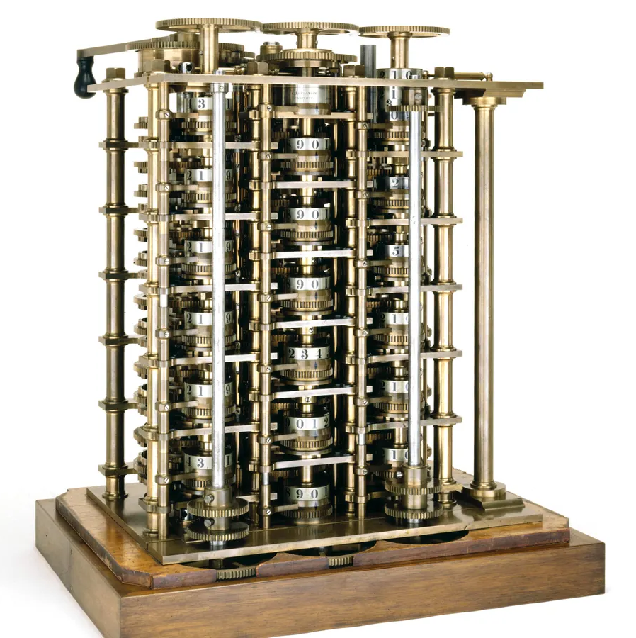During Charles Babbage’s lifetime, this 2,000-part clockwork was as near to completion as his Difference Engine ever got.
Photo credit: Science Museum Group
Read the story about how one of the founding visionaries of modern computing foreshadowed programming, iteration, looping, conditional branching, and built his first working model on June 14th, 1822.

https://spectrum.ieee.org/charles-babbage-difference-engine

$1,000 Worth of Free Credit Card Processing!
If you ever have a need to collect credit card payments be sure to sign up with Square (the credit card processor that MUUG uses) and both you and MUUG will receive $1,000 in free processing for the next 6 months (180 days).
You must use the following referral link to receive the credit:
https://squareup.com/i/MANITOBAU1
Fedora Contributor 2022 Survey
Help shape Fedora’s future
If you’re a Fedora Linux user or a Fedora Project contributor, the development team would love to hear from you!
The survey is open from June 1st to June 30th.
Anyone interested in shaping Fedora‘s future is invited to take the survey.

https://fedoraproject.limequery.com/2022
Have an old outdated iPad?
You might be able to make it run Linux soon!
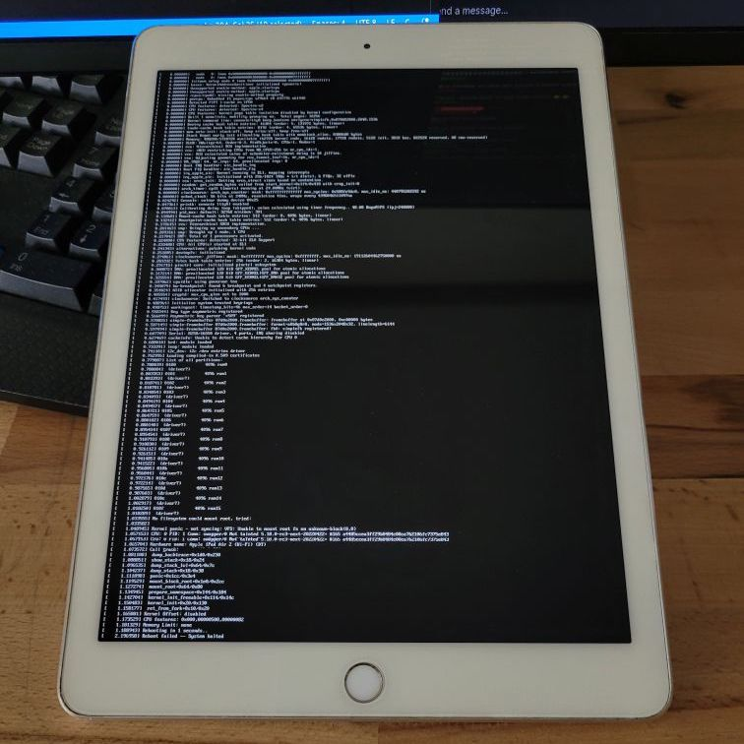
If you have a 2013 or 2014 era iPad sitting around unused because it’s not getting updates from Apple anymore (A7-A8X chips), developers are working on an alternative software solution for you. Developers have collaborated to get Linux kernel version 5.18 booting on an old iPad Air 2, a major feat for a device that was designed to never run any operating system other than Apple’s.
Development work on this latest Linux-on-iDevices effort is still in its early days. For example, it currently can’t mount a filesystem, and basic things like USB and Bluetooth support aren’t working.

https://arstechnica.com/gadgets/2022/06/developers-get-linux-up-and-running-on-old-ipad-air-2-hardware/
3 More Console File Managers
In the June 2016 MUUG newsletter I wrote about the top 6 file managers for Linux. A recent post by Ruben Schade has now introduced me to 3 more:

nnn – Supercharge your productivity!
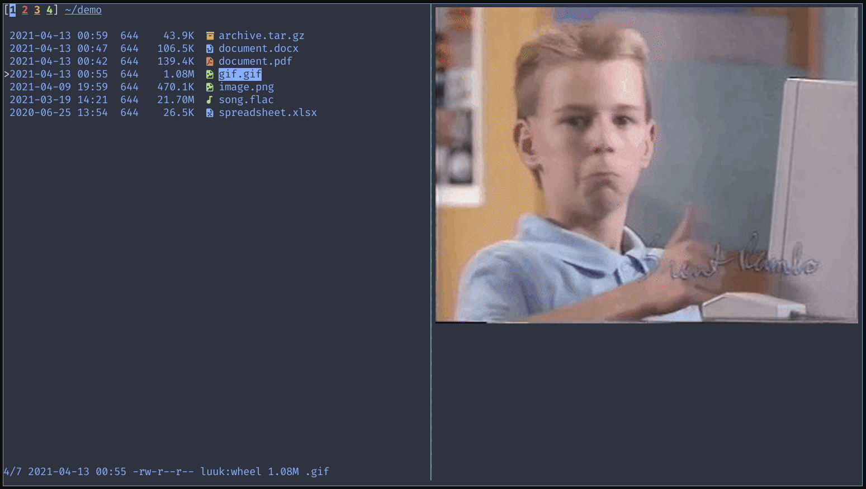
n³ is a full-featured tabbed terminal file manager. It is designed to be unobtrusive with smart work flows.
It can analyze disk usage, batch rename, launch apps, pick files, and has a plug in repository to extend its capabilities further (live previews, (un)mount disks, find & list, file/dir diff, upload files).

https://github.com/jarun/nnn

fff – (Fucking Fast File-Manager)
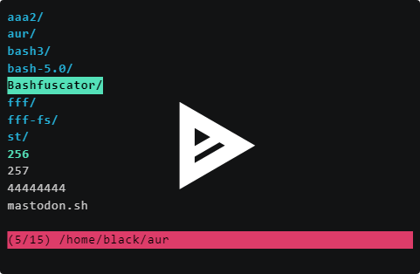
I love the name of this simple file manager written entirely in bash!
It has instant as you type search and tab completion for all commands.

https://github.com/dylanaraps/fff

lf – (as in “list files”)
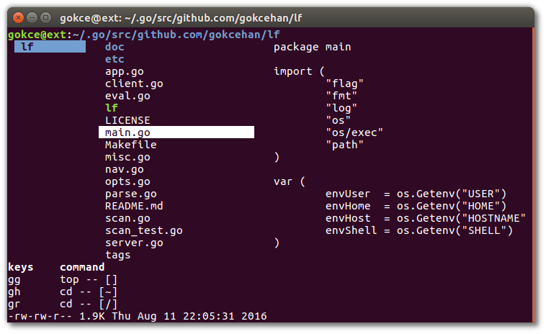
lf is a terminal file manager written in Go with a heavy inspiration from the ranger file manager.

https://github.com/gokcehan/lf
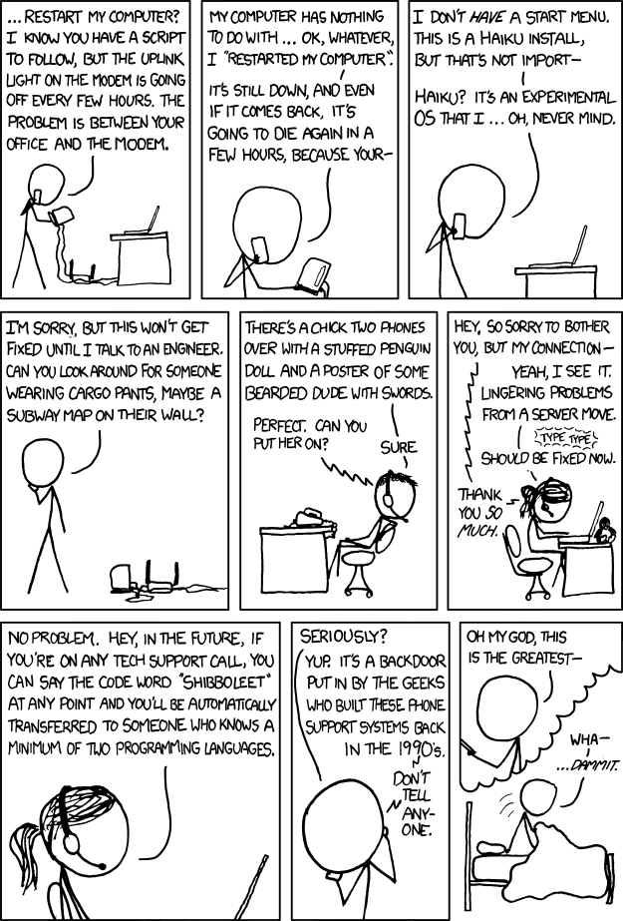Technical Support Calls
If only Shibboleet was real
This newsletter author has been dealing with a Shaw network node/line issue with his entire neighbourhood feed for several months now.
After 20 chats/calls to Shaw support (all starting with the script “can you please unplug and restart your modem” - sigh), 5 tech visits needlessly replacing all the connections from my server to the street, and now multiple bucket trucks working on multiple line connections all over my neighbourhood – with still no improvement – it sure would be nice if “Shibboleet” was true!

https://xkcd.com/806/
Pdfgrep
a command line utility to search text in PDF files
Because of the way plain text is stored in pdf files, grep(1) can almost never find the text you want inside them (even with the -a binary option).
Pdfgrep(1) is here to help you out!
Pdfgrep tries to be mostly compatible with GNU grep with some PDF specific distinctions and some additional PDF specific options.
Most notably, -n prints page numbers (instead of line numbers). And yes Trevor, even -P (Perl compatible regular expressions) are supported!
Here is the difference between grep and pdfgrep searching this newsletter’s pdf for “pdfgrep”:
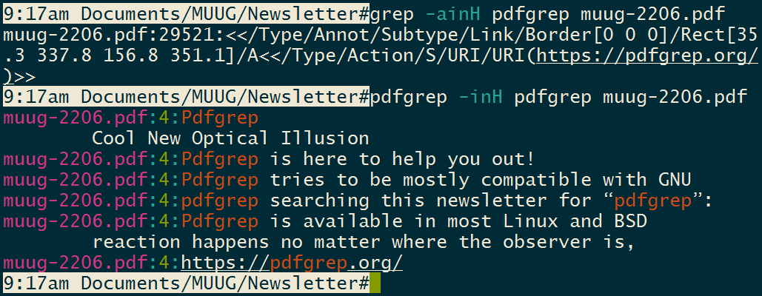
Pdfgrep is available in most Linux and BSD repositories, but is usually not installed by default.

https://pdfgrep.org/
Making the Case for COBOL
On the 14th of March this year the first ever COBOL front-end for the GCC compiler was released.
Unlike the older GnuCOBOL project – which translates COBOL to C (briefly mentioned in our January 2022 MUUG newsletter) – the new GCC-COBOL front-end project does away with that intermediate step, and directly compiles COBOL source code into binary code. All of which raises the question:
why waste an entire man-year of effort for a language which has been declared “dead” for probably at least half its 63-year existence?
Hackaday writer Maya Posh makes a good case for COBOL, and gives some history in a recent article:

https://hackaday.com/2022/05/31/making-the-case-for-cobol/
Cool New Optical Illusion
Research predicts and creates a new optical illusion
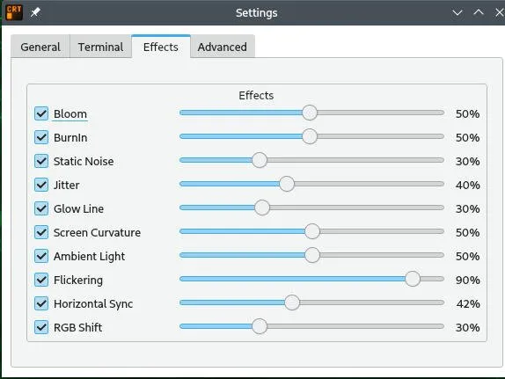
Image Credit: Frontiers in Human Neuroscience
This black blob — created by Akiyoshi Kitaoka as part of research published on May 30th in Frontiers in Human Neuroscience — is set against a pattern of smaller black dots on a white background and is a completely static image. It creates a false sense of movement that also causes the observer’s pupils to expand, according to the study. The physical reaction happens no matter where the observer is, even if they’re looking at the illusion in a well-lit room where pupil adjustments aren’t needed. There’s seemingly no reason for the physical response to occur, but the researchers believe this illusion demonstrates how our brains compensate for the processing time needed to visually perceive the world around us in real-time, and that certain involuntarily reflexes aren’t necessarily controlled by someone’s physical reality.

https://www.frontiersin.org/articles/10.3389/fnhum.2022.877249/full

Things are Getting Rusty in Kernel Land
There is gathering momentum around the idea of adding Rust to the Linux kernel. Why exactly is that a big deal, and what does this mean for the rest of us?
Join the discussion:

https://hackaday.com/2022/05/17/things-are-getting-rusty-in-kernel-land/
Share Your Thoughts

Please email MUUG with your comments and suggestions regarding the newsletter and the meetings. Whether it’s criticisms or commendations, we want to hear from you. Specifically, what sort of material would you like to see and/or hear about.
Send an email to: board@muug.ca.
Creative Commons License

Except where otherwise noted, all content in this newsletter is licensed under a Creative Commons “Attribution-ShareAlike 2.5 Canada” License
http://creativecommons.org/licenses/by-sa/2.5/ca/deed.en_CA
Thank You Les.net

A continued thank you to LES.net for providing MUUG free hosting and bandwidth for our server and mirror. Les.net (1996) Inc. is a local provider of VoIP, Internet and Data Centre services. Contact sales@les.net or call 204-944-0009.

https://les.net
Thank You Michael W. Lucas

MUUG would like to thank Michael W. Lucas for donating one of his ebooks every month as a door prize.
You can view and purchase his tech books here:
https://www.tiltedwindmillpress.com/product-category/tech/

