
MUUGLines
The Manitoba UNIX User Group Newsletter
Volume 35 No. 8, April 2023 Editor: Tyhr Trubiak
Next Meeting: April 4, 2023
*** In Person/Hybrid Meeting! ***
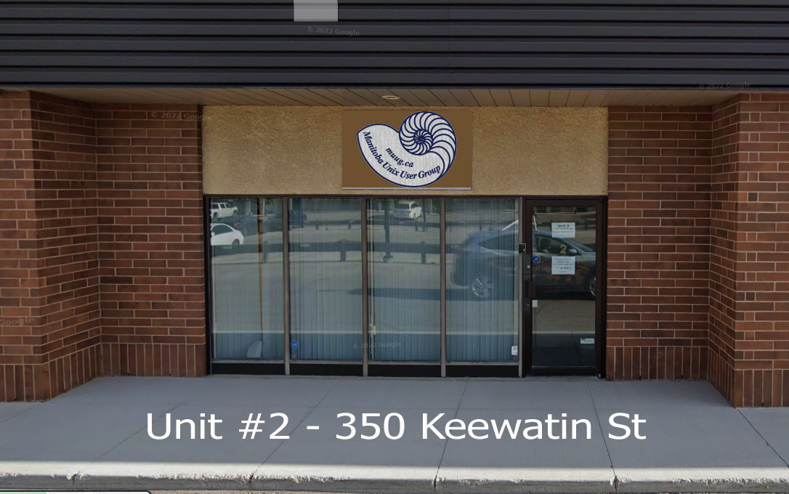

We have a new physical location! We encourage all our members to attend in person and give us feedback.
For those of you that cannot attend in person, we have put in a lot of effort to setup professional grade cameras and microphones with a dedicated stream moderator to enhance the online experience!
The only thing we cannot duplicate online is the free chocolate/cookies/coffee/tea/pop...as well as the ample free parking.
Yes, our new location comes with free dedicated parking lot! (BYOV – Bring Your Own Vehicle, but we will supply the snacks).


This will be an in-person meeting, but please be courteous and stay home if you are not feeling well.
This meeting will also be simulcast over Big Blue Button for those that can't attend in person.
https://muug.ca/meet

Topic: Steam Decks and Steam Desks
Join us this month for a foray into Linux gaming, presented by Chris Audet. We'll discuss Valve's Steam Deck, and similar handheld computers. We'll also cover some notable gaming Linux distros, such as Lakka, and ChimeraOS.

RTFM: termdown - Turn Your Terminal Into a Countdown Timer (or Stopwatch)!
For this month's RTFM, Brad Vokey will give us a quick demonstration of some of the features of termdown. A python countdown timer for the terminal which he has used in the past to countdown the MUUG virtual meeting breaks.


The latest meeting details are always at:
https://muug.ca/meetings/
Where to Find the Meeting:
Fortress Software Inc.
350 Keewatin St – Unit #2
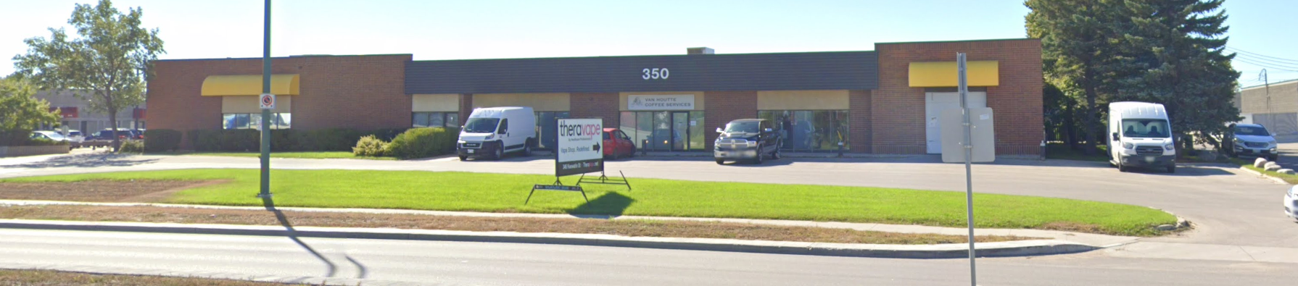
(Please do note that the lack of snow in the picture may not be 100% representative of what you will see when you arrive – we do live in ‘Winterpeg’ afterall)
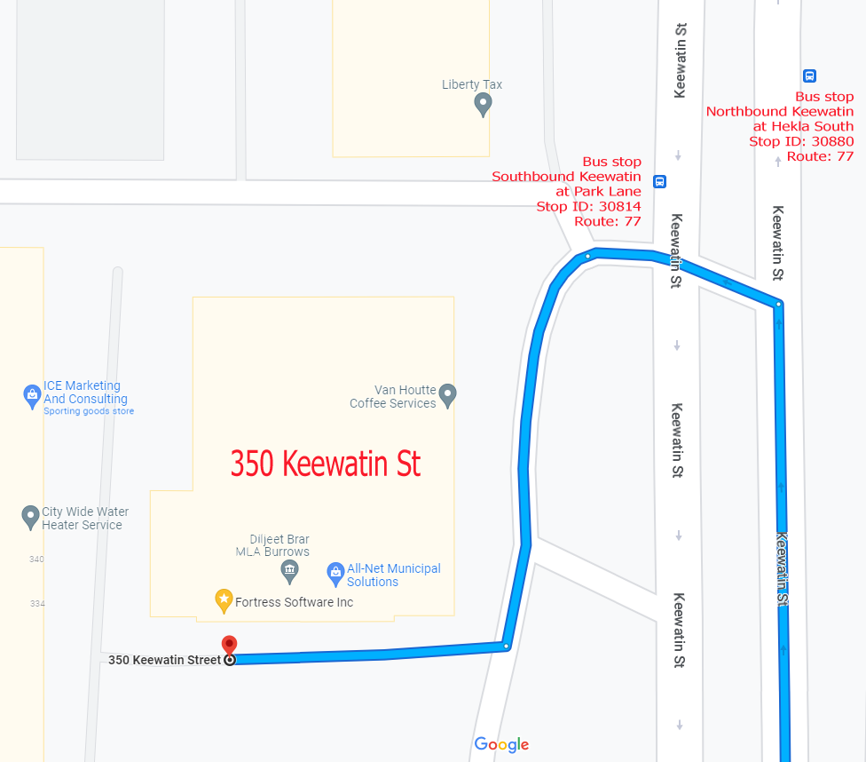
Brad Vokey has graciously let us use his work office for our next in-person meeting.
If you ask nicely (or bribe him), you might get a tour of his Atari computer network that is still operating and currently running his business!
These machines will likely still be running long after the next Amazon Linux distro is retired.
Built to last...or resistant to change...?
The meeting room will be open by 7:00 pm, with the actual meeting starting at 7:30 pm.
If driving, enter the lot using the most north east entrance (far right in the top picture) and drive around to the south west corner of the building (see route in map detail). You can use any of the free, ample, and safe parking spots that say “reserved” in front of units #1 through #4 before entering unit #2.
Bus stops #30814 and #30880 (route 77) are only 150 meters away. The last bus leaves for Polo Park at 10:15 pm and for Garden City at 10:31 pm.
Logan Ave. bus routes #19, #26, and #27 are a 600 meter (8 minute) walk to the south.

GNOME 44 Has Arrived!
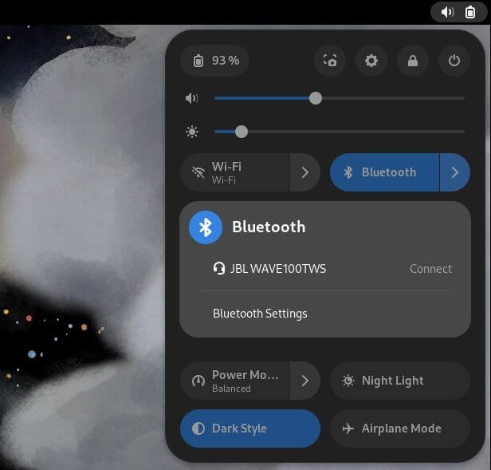
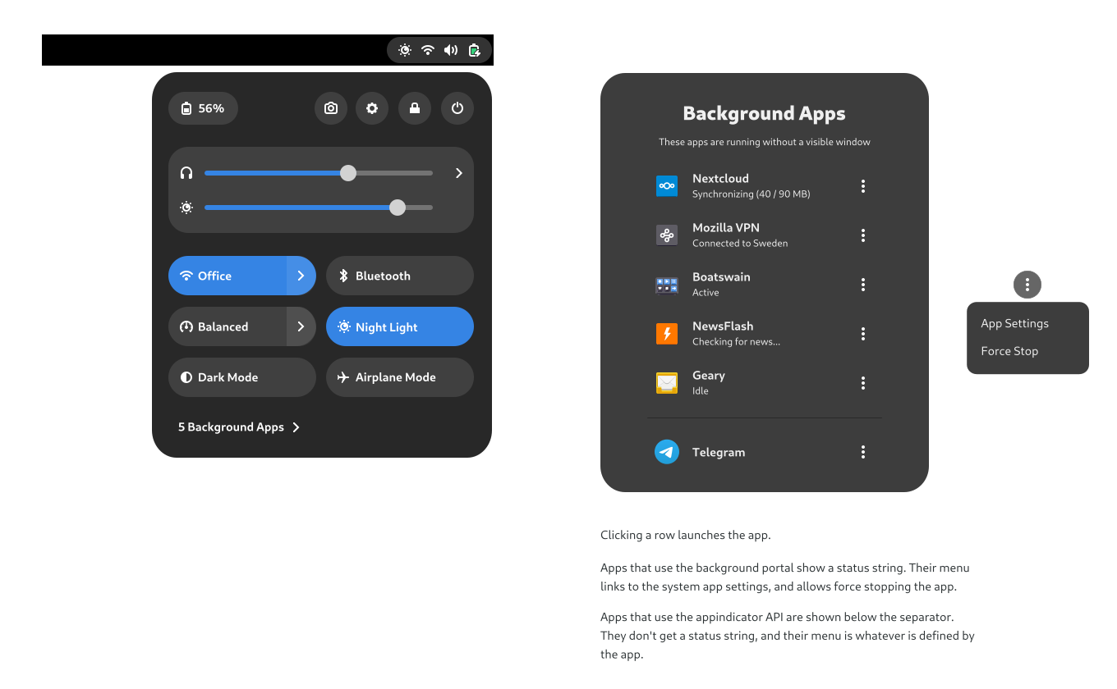
Quick Setting enhancements:
- quickly connect or disconnect Bluetooth devices
- new split-button appearance
- new pod subtitles to relay status (which Wi-Fi network is active, which Bluetooth device is connected, etc)
- quick mute button
- file choose can now display thumbnails
- share Wi-Fi networks with QR codes
- option to disable overlay scroll bars
- about section lists kernel version
- cute animated mouse button/action demonstrations
- quick viewing of background apps

https://www.omgubuntu.co.uk/2023/03/gnome-44-released

UNIX Co-creator
Ken Thompson
Uses Raspian!
Ken Thompson, now at 80 years of age, is a historical icon in the computer world. While working at Bells Labs, Ken helped develop MULTICS, which is the ancestor of UNIX, which he and Dennis Ritchie later developed.
Ken Thompson developed one of the first video games, Space Travel, back in 1969, built UTF-8 encoding, the editor ed, and possibly the first implementation of regex (regular expressions).
At the Southern California Linux Expo, when asked what his operating system of choice is, Ken replied:
“I have for most of my life – because I was sort of born into it – run Apple. Now recently, meaning within the last five years, I've become more and more and more depressed… And what Apple is doing to something that should allow you to work is just atrocious… But they are taking a lot of space and time to do it, so it's okay. And I've come, within the last month or two, to say: even though I've invested a zillion years in Apple, I'm throwing it away, and I'm going to Linux. To Raspbian, in particular.”
Raspbian (now called Raspberry Pi OS) is an operating system based on Debian, optimized for the Raspberry Pi.
Of course, Ken Thompson has a reputation of being quite a character and possibly enjoys trolling people, so one never knows for sure.
One of the most entertaining tidbits I found out was that Ken caused some "hiring problems" when he worked at Google co-developing Go, because he refused to take the company's mandatory C proficiency test...
...on the pretext that he designed the C language...

https://www.theregister.com/2023/03/17/ken_thompson_is_a_maccie/

Amazon Announced the Availability of Amazon Linux 2023.
Amazon promises three (broad) benefits:
1. a high-security standard
2. a predicatable lifecycle
3. deterministic updates
For security, Amazon's latest operating system will come with pre-configured security policies aligned to help your system meet various common industry guidelines. These policies can be configured during launch or run time. The kernel will also be hardened .
What is a predictable lifecycle? Amazon says it's releasing a new version every two years. These new versions will include larger updates to the kernel, toolchain, GLib C, OpenSSL as well as other system libraries and tools.
Quarterly updates will include security patches, bug fixes and new features and/or packages.
Of course, security updates will be made available when they are ready.
Support for each version of Amazon Linux will be five years. After the initial two years and the release of the subsequent version, the older release will be put into its maintenance phase, receiving just security patches and bug fixes.
What are deterministic updates?
“Amazon Linux provides you with deterministic updates through versioned repositories, a flexible and consistent update mechanism. The distribution locks to a specific version of the Amazon Linux package repository, giving you control over how and when you absorb updates. By default, and in contrast with Amazon Linux 2, a dnf update command will not update your installed packages (dnf is the successor to yum). This helps to ensure that you are using the same package versions across your fleet.”

https://www.neowin.net/news/amazon-linux-2023-a-cloud-optimized-linux-distro-is-now-available/

Help Skynet Find John Connor – Use ChatGPT in Your Linux Terminal by Installing ShellGPT
ShellGPT harnesses the power of ChatGPT right in your Linux Terminal. Want to ask it questions? Tell it to write code for you? It will even execute shell commands based on your input. What could possibly go wrong?...
ShellGPT is a Python based command line version of ChatGPT, based on OpenAI’s GPT large language model, that provides an interface of engagement with the popular AI chatbot.
Instructions to install on an Ubuntu system are provided in this link. Users of RHEL-type systems may have to massage their installs a little, with such things alternates as:
yum install python36-devel python36-setuptools python36-virtualenv
You will also need an OpenAI API key. Currently, OpenAI is offering a limited trial use ($5 worth) for free.
Of course, some of you may realize that nothing in this governed world is free. You will either have to pay a monetary value, give up certain freedoms or even pay with your health...but if you already know this, you are part of the problem that Skynet plans to correct...
Hmmm...let me test sgpt “create muug newsletter” before my social credit score gets too low...
https://beebom.com/how-use-chatgpt-linux-terminal/
NetBSD Repo is 30 Years Old!

That makes it one of the oldest actively developed repositories on the internet!
Although the NetBSD repo is still younger than MUUG, which had it’s first official meeting back in 1986! I may be comparing apples to oranges, but some of our MUUG members are still actively developing too!
Finally a New Display Driver for a 1992 Computer!
Geert Uytterhoeven, the maintainer of Linux/m68k, the Motorola port of the Linux kernel reports:
“The RFC patch series adds a DRM driver for the old Atari ST/TT/Falcon hardware.”
The new driver he developed is ran entirely on emulated hardware, using a virtual machine called ARAnyM (by Czech developer Petr Stehlík).
So keep that in mind when anyone asks about the status of some of your older project ideas...we will eventually get around to it...

https://www.theregister.com/2022/12/05/new_atari_display_driver/
Using the “at” Command to Schedule
Don’t we just use cron to schedule tasks in Linux?
Yes and no.
cron allows you to schedule tasks to be run on a specific schedule, such as certain times of the day, week, month, etc.
at runs only once.
$ at 23:00
at> echo “go to bed!”
at> <EOT>

(end the at command by pressing ^D)

Dates can be in various formats, such as:
13:41 tomorrow
noon Wednesday
MMDD[CC]YY
MM/DD/[CC]YY
DD.MM.[CC]YY
[CC]YY-MM-DD
To list your jobs:
$ atq
To delete a scheduled job, use atrm [job number]
Runs only once? Can I schedule it to schedule something else?
...AT-AT?
$ at midnight on Endor
at> at bedtime of Ewoks...
Yes, yes you can!

https://www.networkworld.com/article/3690617/using-the-at-command-to-schedule-tasks-on-linux.html

A big thanks to Les.net for providing MUUG with free hosting and all that bandwidth! Les.net (1996) Inc. is a local provider of VoIP, Internet and Data Centre services. Contact sales@les.net by email, or +1 (204) 944-0009 by phone.
MUUG would like to thank Michael W. Lucas for donating one of his ebooks every month as a door prize. You can view and purchase his tech books here:

https://www.tiltedwindmillpress.com/product-category/tech/
Except where otherwise noted, all textual content is licensed under a Creative Commons Attribution-ShareAlike 4.0 International License.

https://creativecommons.org/licenses/by-sa/4.0/

