MUUGLines
The Manitoba UNIX User Group Newsletter
Volume 25 No. 6, February 2013 Editor: Gilbert Detillieux
Next Meeting: February 12th, 2013

Presentation: System Call Tracing
This month’s presentation will feature Adam Thompson, who will show how to profile and troubleshoot UNIX processes without needing access to source code, through the use of system-call tracing. Learn where, when, why (and for a few of these, how) to use dtrace, dtruss, ftrace, ktrace/kdump, ltrace, LTTng, par, ProbeVue, ptrace, strace, System Tap, tusc, trace, and truss to find out exactly what that troublesome program is doing behind the scenes.
Where to Find the Meeting
1L08 Lockhart Hall, University of Winnipeg
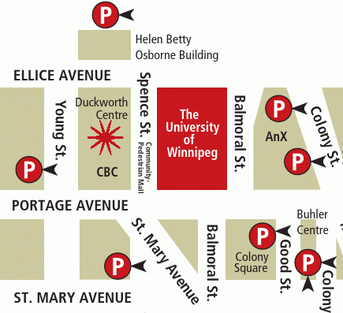

Important: MUUG Has Moved
Our new home is at the University of Winnipeg in Lockhart Hall, room 1L08; indicated on the map above by the big red rectangle. Enter Lockhart Hall on Ellice Ave., between Spence St. & Balmoral St. Parking is available on the surrounding streets and in the lots indicated above by the letter P. Look for signage once you’re at the building, or ask a security guard.
Upcoming Meeting

March 12th, 2013
Topic: TBD
Location: University of Winnipeg, room TBA
Newegg Wins on Appeal Against Shopping Cart Patent Troll
Recently reported on Ars Technica, a so-called “patent troll” company has just been dealt a serious blow, when an appeal by Newegg resulted in the invalidation of three of their patents, which they had used to sue or settle with numerous online retailers. Soverain Software, a sham technology company set up by a venture capital fund to manage the patents of a defunct company called OpenMarket, seems to exist for the sole purpose of filing lawsuits against online retail companies using shopping carts on their sites.
Newegg’s lawyers have adopted a policy of not settling with patent trolls, but rather fighting them in court at all costs. When they lost against Soverain in a 2010 East Texas jury trial, which awarded the plaintiff $2.5M (much less than the $34M they had asked for), Newegg’s chief legal officer, Lee Cheng, felt they had sufficient grounds for appeal. Soverain now stands to lose even larger amounts awarded in trials against Victoria’s Secret and Avon, and also loses its grounds for several pending lawsuits against other retailers.

http://arstechnica.com/tech-policy/2013/01/how-newegg-crushed-the-shopping-cart-patent-and-saved-online-retail/
Cisco Sells Linksys to Belkin
Our friends at The Register reported on January 25th that Cisco has found a buyer for the lower-end Linksys brand, which they had bought in 2003 for US$500M. The details of the sale are not known at this time, but will involve an ongoing strategic relationship between the two companies.

http://www.theregister.co.uk/2013/01/25/belkin_buys_linksys/

IBM Predicts Steampunk Next Big Fashion Trend
Also from The Register comes this slightly disturbing prediction of the next mainstream fashion trend: steampunk. Yep, apparently, IBM has been using its vast array of computing power to churn through data from social media sites, looking for trends, and has zeroed in on steampunk as the next big one. The neo-Victorian retro-fad that’s been popular with a small but very dedicated segment of the geeky SF crowd, is about to go mainstream, affecting designs for clothing, jewellery and accessories. Or maybe it’s just wishful thinking on the part of the centenarian IBM...

http://www.theregister.co.uk/2013/01/15/ibm_steampunk_sentiment_analysis/
Google’s SPDY to be Included in HTTP 2.0
And in further news from The Register (albeit a little less recent news, but still significant nonetheless), Google’s SPDY (pronounced “speedy”) protocol has received approval from the IETF for inclusion in the HTTP 2.0 standard, which is in the works.
SPDY is part of Google’s efforts to speed up communications between web browsers and servers, and offers the following features:
- Compression of request and response headers, including cookies,
- Multiple simultaneous requests over a single connection, to avoid lower-priority (and lower speed) requests from blocking higher-priority ones,
- Ability for servers to actively push resources such as scripts and CSS without waiting for a client request.
SPDY is designed to be compatible with current HTTP and adds functionality by layering on top of it. It’s already been added into Chrome, Firefox, Opera, and Amazon’s Silk browsers.

http://www.theregister.co.uk/2012/12/03/google_spdy_included_in_http_2_draft/
The Chromium Projects web site includes lots of documentation on this protocol and its features.

http://www.chromium.org/spdy
Pi to Go:
A DIY Portable
For those of you looking for interesting projects to build around your Raspberry Pi single-board computer, Parts-people.com has an article describing how to build a mobile Pi-to-Go. It features an LCD screen, battery pack, internal powered USB hub, SSD storage, built-in WiFi & Bluetooth, and a mini keyboard & touchpad. You can even download an STL file to print off your own case for it, if you happen to have a 3D printer kicking around. Aside from the case, all other parts are available for purchase from various sites, for less than $400.

http://blog.parts-people.com/2012/12/20/mobile-raspberry-pi-computer-build-your-own-portable-rpi-to-go/
Lifehacker Raspberry Pi Week
If building a Pi-to-Go is a bit too ambitious for you, but you’d like to start doing something with your RPi, you might be interested in a week-long series of DIY articles from Lifehacker, which featured these topics:
- Install Raspbian and get started with Raspberry Pi DIY,
- Build an XBMC-powered media centre,
- Set up a personal VPN for secure access anywhere you go,
- Create an AirPlay receiver and stereo companion.
What are you waiting for? Get building!

http://lifehacker.com/5976912/a-beginners-guide-to-diying-with-the-raspberry-pi

XBMC 12 “Frodo” on RPi, Android
Also from Lifehacker comes the news that “Frodo,” the code name for XBMC 12, is available, with support for Raspberry Pi, initial support for Android, 64-bit support in Mac OSX to match the 64-bit Linux support, among other improvements. Here’s the site for this and other Pi-related news at Lifehacker:

http://lifehacker.com/raspberry-pi

More Pi Hacks
And if you still haven’t had your fill of Raspberry Pi projects, IT World has a dozen or so weird and wonderful hacks, including airborne and waterborne devices, a solar-powered FTP server, a tiny arcade console, and (I’m not making this up) a device called BeetBox that lets you play drumbeats by touching real beets.

http://www.itworld.com/hardware/337460/10-weird-and-wonderful-raspberry-pi-hacks
LibreOffice 4.0 Release
The Document Foundation has announced that it will release version 4.0 of LibreOffice in the beginning of February. Why the increment in the major version number? A number of reasons, they claim, with these being the two major ones:
- Major changed in the API, marking “a more radical departure from the OpenOffice.org codebase... LibreOffice 4.0 is becoming a different animal.”
- A new graphics stack, with new UI widgets, cleaner looks, and interface improvements.

http://standardsandfreedom.net/index.php/2013/01/24/the-meaning-of-the-4-0/
Opera Ice Based on WebKit
Opera Software is launching a new mobile browser, called Opera Ice, this month. It will be available for iOS and Android devices, and (surprisingly) will be based on WebKit, and not the Presto platform.
“This is a full touch and tablet-focused browser,” claims Opera’s product manager.

http://www.pocket-lint.com/news/49375/opera-ice-new-webkit-browser
Much Ado About Systemd
While Red Hat and Fedora continue to back systemd as their system initializer and service manager, not everyone in the Linux community is quite as happy with it. Distrowatch reports that Gentoo Linux “have already forked udev (which is now an integral part of systemd), after accusing the upsteam of removing useful features and generally being uncooperative.”
Lennart Poettering, systemd developer, countered with a blog posting called “The Biggest Myths”:

http://0pointer.de/blog/projects/the-biggest-myths.html


BB10: Is RIM Cool Again?
The Canadian media are all a-twitter about the February release of RIM’s two new Blackberry 10 smartphones! RIM is going all out in promoting this new release, with simultaneous live events in Toronto, New York, London, Paris, and several other cities around the world. RIM hopes BB10 will turn the company’s fortunes around. They’ve even enlisted the help of Alicia Keys to push this one.
The touchscreen-based Z10 will be available in Canada on February 5th, with the Q10 (the keyboard version) being available at a future date. The BB10 operating system, based on the multitasking QNX kernel, will allow RIM to offer many new services and apps on the new phones, but will it be enough to allow RIM to catch up to iOS and Android, which now dominate the market?

http://www.cbc.ca/news/technology/story/2013/01/29/business-rim-blackberry.html

http://www.osnews.com/story/26704/What_is_BB10_s_identity_
Book Review:
The Linux Command Line
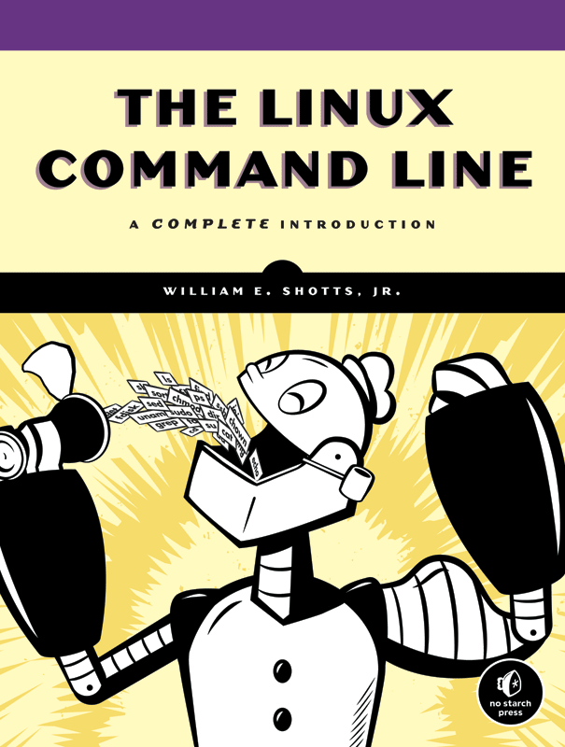
William E. Shotts, Jr.,
No Starch Press, 2012
Reviewed by
Michael Doob
There is no shortage of material to include when discussing Linux from the command line. Indeed, one could argue that all of Linux is covered under this topic. How many such commands are there? On my home Linux installation, there are 4850 man pages starting from a2ps and going through zsoelim.
A book with somewhat over 400 pages will have to do a lot of culling. The challange, then, is to have a coherent presentation that is aimed at a specific technical ability. The real decision is what to leave out.
There are several levels of Linux tasks that might be addressed by such a book:
- Run installed software clients, perhaps with parameters.
- Manipulate files within the user filespace.
- Edit text files.
- Perform simple numercial calculations.
- Do basic text processing.
- Use pipes to make simpler tools carry out more complex functions.
- Use scripts to extend sequences of command line functions.
- Use tools that interact with the operating system.
- Reconfigure the operating system.
- Compile operating system utilities and tools.
- Compile independent programs from source code and libraries.
The first decision made by the author is the choice of shell. He uses bash, the only logical option in today’s environment. The next decision is which of the topics listed above should be addressed. Since the author has the intent of showing the typical Windows user the advantages of command line computing, the topics are chosen by dividing the book into four parts of increasing complexity.

Part 1: Learning the Shell
This part certainly assumes no prerequisites. It starts with the commands date, cd, and ls. When trying to teach a beginner, it is necessary to decide which topics should not be addressed, not because they are unworthy, but rather because they too confusing the first time through. This book needs some pruning. For example, after introducing cp, mv, mkdir and rm, there is a discussion about the difference between soft and hard links. This is a worthy topic, but not for someone learning who is just learning to remove files. Similarly, when discussing redirection, the uses of /dev/null or redirecting of standard output and standard error to one file could probably wait for later. The first quarter of this book is a collection of commands, all of which are useful at some level. It would have been better to have the levels differentiated.

Part 2: Configuration and the Environment
This part is rather odd. Most of it is an introduction to vi. The important discussion of user environmental variables (like $PATH) is limited to a few pages. A significant section is given to the less important topic of customizing the prompt.

Part 3: Common Tasks and Essential Tools
This part covers a collection of tools commonly used from the shell prompt. For example, package managers (yum and apt-get) are discussed as a method for installing new packages, but, oddly enough, not as a method of updating the operating system.
The topics in this section were also somewhat uneven in level. The section on networking includes tools such as ftp, wget and ssh, topics useful to to newer Linux user. But then netstat is introduced, a much more sophisticated command (in fact ifconfig would have been just as good).

Part 4: Writing Shell Scripts
The last quarter of this book is an introduction to writing shell scripts. The topics included are pretty standard: advantages of scripts, top-down design, flow control, looping and the like. The level of discourse remained pretty consistent. The goal of this part was to enable the relatively unsophisticated user to write useful scripts. It is successful.
In summation, this book is rather uneven; it jumps around in the assumed level of understanding of the reader. The first and fourth part are good for the new Linux user. The middle parts are a bit of a hodge-podge.

