
MUUGLines
The Manitoba UNIX User Group Newsletter
Volume 35 No. 9, May 2023 Editor: Trevor E Cordes
Next Meeting: May 2nd, 2023 7:30pm
In Person and Online
For the third month in a row the meeting will be held both physically in person, and online via our Big Blue Button videoconferencing server. We encourage all members to attend in person. If you cannot attend in person, you can watch and interact with the meeting online and partake of our professional grade camera, microphone and dedicated stream moderator.

If you show up in person you will be treated to more beverage choices than we’ve offered in over a decade: coffee, tea, and pop, as well as cookies. And parking is free, copious, safe, and just a handful of feet from the door.
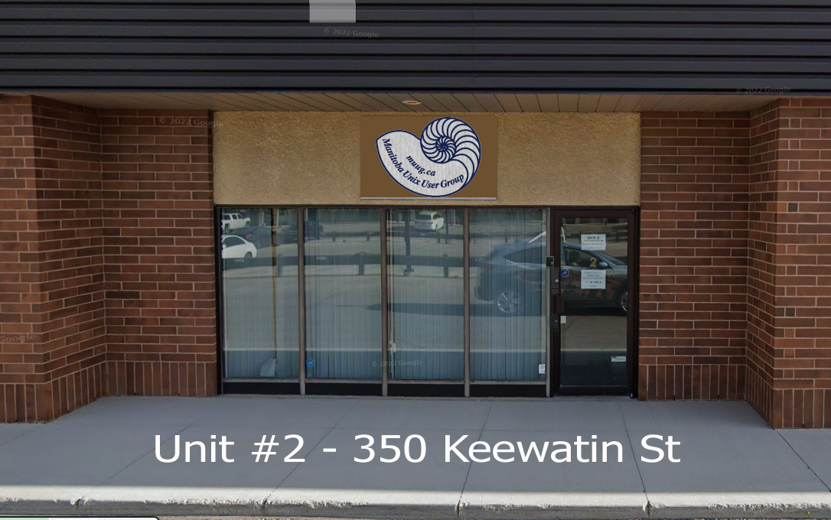
Please stay home if you are sick that day.


To attend via internet, check and refresh the following link after 7:00pm. There is no need to create an account in BBB, nor login. Just enter any name as your screen name and hit join.

https://muug.ca/meet

Presentation: Ansible AWX
"AWX provides a web-based user interface, REST API, and task engine built on top of Ansible."
In this presentation, Alberto Abrao will show how to set it up, and basic usage.

The latest meeting details are always at:

https://muug.ca/meetings/
Where to Find the Meeting

Note again the early meeting date of May 2nd, after our recent change to the first Tuesday of every month. Update your calendars!
Fortress Software Inc.
350 Keewatin St – Unit #2
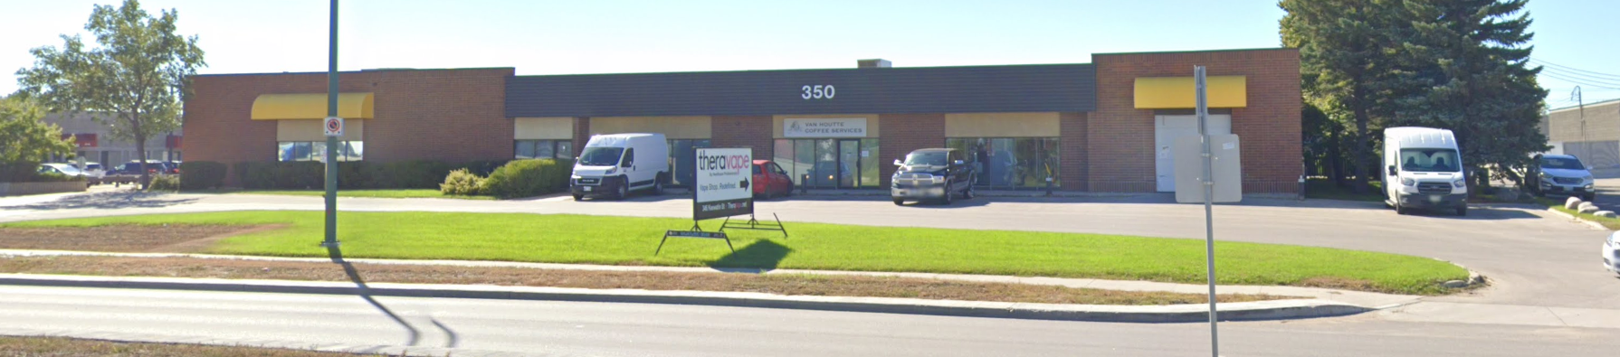
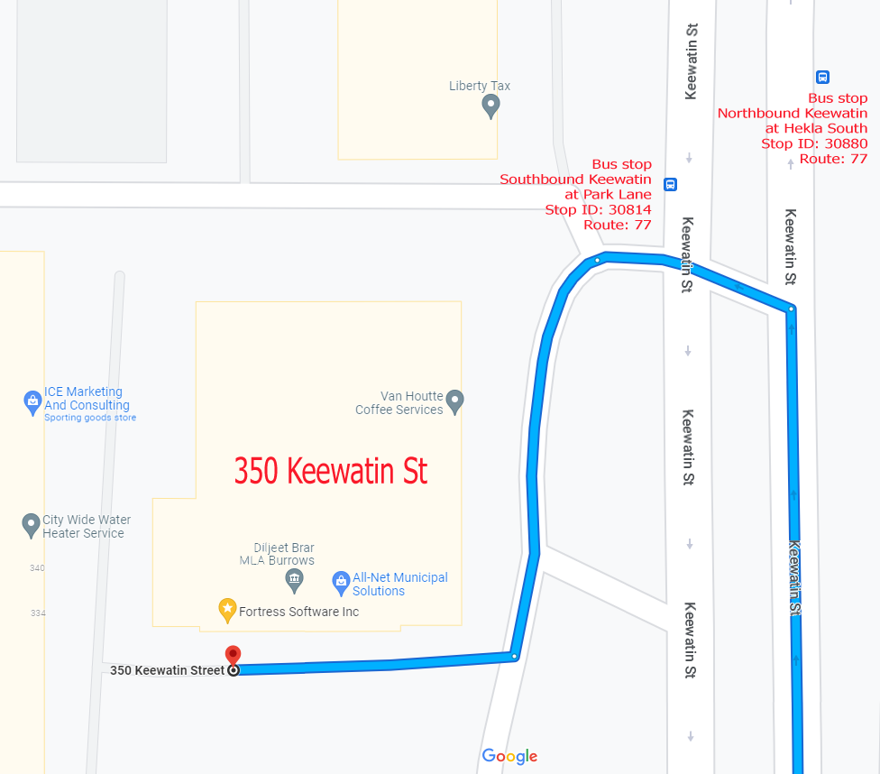
MUUG Treasurer, Brad Vokey, has once againgraciously donated use of his work office. Doors will open at 7:00pm. Meeting starts at 7:30pm.
If driving, enter the lot using the most north-eastern entrance (far right in the top picture) and drive around to the south west corner of the building (see route in map detail). You can use any of the free, ample, and safe parking spots that say “reserved” or “MUUG” in front of units #1 through #4 before entering into unit #2. Look for the sign!
Bus stops #30814 and #30880 (route 77) are only 150 meters away. The last bus leaves for Polo Park at 10:15 pm and for Garden City at 10:31 pm.
Logan Ave. bus routes #19, #26, and #27 are a 600 meter (8 minute) walk to the south.
Door Prizes
We have dead trees! This month we will be giving away as one of the door prizes a physical copy of 97 Things Every Information Security Professional Should Know on O’Reilly.
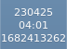

Their 97 Things series has been going on for a while now and is similar to, and somewhat replaces, their older Hacks series. Each one is a mash-up of on-topic anecdotes and tidbits deemed to be of the most importance by each contributing author.
Whether you’re searching for new or additional opportunities, information security can be vast and overwhelming. In this practical guide, author Christina Morillo introduces technical knowledge from a diverse range of experts in the infosec field. Through 97 concise and useful tips, you'll learn how to expand your skills and solve common issues by working through everyday security problems.
New for this month, your choice of *NIX-themed stickers will be offered as a couple of prize draws. See the Stickers section later in this newsletter.
Additionally, a few Communications of the ACM magazines graciously donated by Dan Keizer will be up for grabs as door prizes. And, as usual, we will be giving away a couple of e-books, including one graciously donated by Michael W. Lucas of Tilted Windmill Press.
Everyone is encouraged to enter the door prize draw, both in-person and virtual attendees. You don’t have to be a member to enter, but members have exclusive access to the first draw. Members also get the privilege of not having to be present (physically or virtually) for the draw in order to claim their prize.
*NIXy Stickers Have Arrived
MUUG has acquired some very fine stickers from StickerMule. We’ll be giving some away as door prizes. Show up in person to the meeting and check out the full assortment! Surely one must match your favorite distro? Can anyone spot Gentoo (you know who you are!).
Want your own complete set? Use this special link to receive a $12.50 credit towards your order. Be sure to use the link to sign up before trying to buy anything. Minimum purchase may apply.
The special *NIX sticker pack can be hard to find on their website, so use this link instead.
Fedora 38 Arrives Early
Well that’s unusual for the usually-late distro: Fedora 38 launched April 17 - one-week early. And their newly-revamped website launched at the same time.

https://fedoraproject.org/
New in this version is a separate Budgie DE Spin promising a desktop of “simplicity, minimalism and elegance”; a Sway Spin if you like tiling WMs and Wayland; or the Phosh image to get Gnome and Wayland on your Pine/Purism phone!
You also get GNOME 44, with various tweaks and speed improvements. For those with IBM Z hardware sitting in their living room, you get better performance and more features by Fedora’s pegging the minimum supported system to z13. To beef up security, rpms are now built with stricter compiler flags, and rpm now “uses a Sequoia-based OpenPGP parser instead of its own implementation”. “Framer pointers” are now built into official rpms to aid in application performance profiling.
gcc has been bumped up to version 13, Ruby to 3.2, and PHP goes to 8.2. What fresh hell awaits the unsuspecting PHP dev? Watch this space over the next year!
https://fedoramagazine.org/announcing-fedora-38
XFCE Clock Outgeeks Everyone
Do you use XFCE, the lightweight, yet very usable and customizable Windows-95esque desktop environment? The panel clock widget has a wonderful format option you might not know about: %s. It shows you the seconds-since-epoch, otherwise known as unixtime.
Yes, you can impress and amaze your friends (and surely win new ones) when they see that it is currently 1682413262. Great for programmers who have to deal with unixtime and need to do a quick comparison.
This author’s format string of choice: %y%m%d%n%R%n%s
Procmail Debugging
Do you use procmail, the handy email MDA (local delivery agent) and have some complicated recipes? Ever have one (especially a pipe) misbehave? Debugging recipes is very hard with the default config. Things clearly aren’t working, yet there is very little info and output provided.
Never fear, procmail includes some very powerful debugging options. Start by adding VERBOSE on to your .procmailrc file. It gives you some extended diagnostics.
If your problem is with a pipe recipe, the handiest feature is output capture. The syntax for that is:
somevar=|/bin/yourcommand

So now you have the command output in somevar; how do you retrieve it? With the LOG option:
LOG=”$somevar, context:`id`”

The output will be saved in your normal procmail log alongside the usual From/Subject/Folder information. Furthermore, the example above demonstrates you can include arbitrary strings and command substitution in the log as well. This example will follow the somevar contents with the output from id as run at the time of the email receipt/processing.
The LOG option can span many lines – just don’t close the double quote until the end – and can contain any number of substitutions.
Tux Paint: Linux For Kids
Have young kids or grand kids? What’s a great way to introduce kids to Linux and/or FLOSS in general? Kids games! My kids’ first experience with Linux was a fun and friendly kids drawing program called Tux Paint. Bring this program up in front of any 2 to 8 year old and then try to keep them away from it. (Literacy is not required.)
Tux Paint is a simplified drawing program that is super easy to use, teaches kids mouse skills, and provides captivating visual and aural feedback.
Easily the most popular feature is the “stamps” which will plunk down a copy of a (usually) full-color picture or icon of, and in the shape of, an object such as an animal or vehicle. Many stamps have a sound sample attached to them which plays each time you stamp it. The sound for many birds and the lightning stamp are particular favorites.
You also get access to many features of a “normal” drawing program, such as shapes, text, fills, and more. After your kid has painted some modern art masterpiece, they can move on to the “magic” feature which lets them blend, blur, distort, fisheye, and otherwise “paint on” wacky and interesting effects – each with its own unique sound.
When they are done they can save or print their creation. The best part is even very young kids can play unattended for quite a long time while daddy gets his programming work done.
You don’t even have to use Linux to use this game: it’s also available for Windows, Android and MacOS. Note: on many Linux distros, many of the stamps that make the program so fun are in a separate package you must install. In Fedora its called tuxpaint-stamps.
DoomLinux Is What It Sounds Like
Ok, so you like Doom, that ancient, genre-defining DOS game. But you can’t be bothered to wait for your box to boot up and fudge around with logging in and finding and clicking on its launcher. Well, some odd soul shares your pain; and has a solution!
Anyone can roll their own Linux distribution with the right tools, including [Shadly], who recently created one which only loads enough software to launch the 1993 classic DOOM.... It loads the Linux kernel and the standard utilities via BusyBox, then runs fbDOOM, which is a port of the game specifically designed to run on the Linux framebuffer with minimal dependencies.
Write it to a USB stick and boot it on any x86 PC.
Watch the craziness it in action here:

https://www.youtube.com/watch?v=VaALEKWQOpg
MUUG would like to thank Michael W. Lucas for donating one of his ebooks every month as a door prize. You can view and purchase his tech books here:

https://www.tiltedwindmillpress.com/product-category/tech/
Fedora Wins Over Amazon
The third, and latest, version of Amazon’s Linux distro Amazon Linux 2023 is based on Fedora, using a mixture of components from Fedora 34, 35 and 36. Stir them together and AWS gets the “long-term, stable OS for the cloud” it wants.
A big thanks to Les.net for providing MUUG with free hosting and all that bandwidth! Les.net (1996) Inc. is a local provider of VoIP, Internet and Data Centre services. Contact sales@les.net by email, or +1 (204) 944-0009 by phone.
Help us promote this month’s meeting, by putting this poster up on your workplace bulletin board or other suitable public message board:

https://muug.ca/meetings/MUUGmeeting.pdf
Except where otherwise noted, all textual content is licensed under a Creative Commons Attribution-ShareAlike 4.0 International License.

https://creativecommons.org/licenses/by-sa/4.0/

